**IMD - Deposit Runoff Assumption and Deposit Rate Beta Calculation**

**(Model ID: 2432)**

**Model Owner:** Randy Ahluwalia, IRR-ALM

**Model Developer:**  Randy Ahluwalia

**Model User**: Corporate Treasury

**Documentation Date:** July 1, 2016

## Purpose and Use

### Purpose of Model

The model presented herein is used for the valuation of non-maturity deposits. It has two main components: a balance runoff function and a repricing function. Deposit valuation and interest rate risk profile drive the Economic Value of Equity (EVE) sensitivity, and impact regulatory Interest Rate Risk in the Banking Book (IRRBB) and Economic Capital calculations.

### Areas of Use

The model applies to non-maturity deposits across BNY Mellon. It is used for deposits valuation as well as Economic Value of Equity (EVE) sensitivity analysis, as part of Corporate Treasury’s interest rate risk management.

### Model Family

This model is part of the interest rate risk models used by Corporate Treasury and connects to other models as specified below:

* Characterization of operational deposits as designated within the Operational Deposit Model #2458 is an input to the model.
* The output is used in model QRM for EVE calculation #2359, including EVE baseline and sensitivity analysis.
* The output is used in Interest Risk EC Model #2436.

### Limitations

The model owner recognizes the following limitations:

* The balance runoff function is based on decay rates observed at the account level over five years from January 2010 to February 2015, which does not cover a complete economic cycle and consequently diminishes the model ability to forecast runoff for economic regimes that are unlike the regime prevalent over our model’s calibration horizon. This will be enhanced once BNY Mellon collects more data spanning an entire economic cycle. Due to additional data limitations, the SA/NV model is based on ALMIS data only, which spans from December 2013 through October 2015.
* No interest rate sensitivity is embedded in the balance runoff function due to data limitations. Specifically, the interest rate regime during the modeling timeframe is very stable and low. Therefore it is difficult to model the interest rate impact to balance runoff. However, we do not have evidence that this insensitivity will survive interest rate regime changes. In order to mitigate this weakness, we take the compensatory action to runoff the portion of the balance that is qualitatively assumed to be Non-Core funding at 100% overnight. Once the interest rate regime changes, the interest rate sensitivity will be closely monitored and tested.
* Deposits life is truncated at 10 years in QRM as an additional compensatory action for mitigating the model risk arising from the above weaknesses. Sensitivity analysis to this truncation assumption is provided in the Appendix.

## Background

In 2013, the Federal Reserve identified the following weaknesses in the methodology for modeling cash flow attrition of non-maturity deposits:

* Attrition is dependent on account balance size
* Attrition estimates do not use empirically proven drivers of attrition observed at other institutions

Management agreed to revise its methodology to include empirical factors.

The remediation plan was submitted to the Federal Reserve in November, 2014.

## Model Specification

### Model Approach

As described earlier, the model comprises two components that define the valuation and the interest rate risk profile of non-maturity deposits: the runoff function and the repricing function as shown in the figure below:

**NON MATURITY DEPOSIT VALUATION MODEL**

RUNOFF FUNCTION

REPRICING FUNCTION (BETA)

Non Maturity Deposits

Operational Deposits

Non Operational Deposits

Core Balance = Operational Balance

Non-Core Balance = Excess Balance

Core Balance = Lowest Balance since 2009 (i.e. Aug 2009 balance)

Non-Core Balance = Current Balance - Core Balance

Non Maturity Deposits

Interest-Bearing Deposit?

Linear regression of deposit rates against short term market rates

**Core Balance:** Decay Rate Function

*Core_balance(age) = [1- DR(age)]*Core_balance(age -1)*

**Non-Core Balance:** 100% run off overnight

**Interest Bearing Deposits:** Beta = Slope’s regression

**Non-Interest Bearing Deposits:** Beta = 0

YES

NO

NON MATURITY DEPOSIT VALUATION MODEL

RUNOFF FUNCTION

REPRICING FUNCTION (BETA)

Non Maturity Deposits

Operational Deposits

Non Operational Deposits

Non Maturity Deposits

Interest bearing deposit?

Core Balance = Operational Balance

Non-Core Balance = Excess Balance

* Runoff function:

Deposit balance runoff modeling has traditionally focused on decay rates. The industry uses different approaches for core and non-core deposits. For core deposits, a decay rate function based on the age of an account is commonly used to estimate balance runoff. For non-core deposits, a single or multiple factor model is used based on analysis of interest rate drivers of balance runoff.

BNYM adopted the following approach: BNY Mellon developed the decay rate function based on all deposits (core and non-core). However, the decay rate function is applied to the c*ore* deposit balances as detailed in the Formulation section below. The function will result in faster decay because of inclusion of non-core deposits in its calibration data. Therefore, this overlay introduces a conservative bias to the model. Further, to compensate for inability to build an interest rate driven function for *non-core* deposits, 100% of those balances are assumed to run off overnight. This assumption introduces an additional layer of conservatism to the model.

* Repricing function:

Beta sensitivity is defined here as the linear relationship between customer deposit rates and short-term interest rates. It is calculated by regressing customer deposit rates at the line of business and product level against short-term rates over a given historical period.

### Methodology

#### **Runoff Function**

##### **Assumptions**

Assumption 1: The balance runoff can be approximated by the attrition rate of number of active accounts.

Assumption 2: The decay rate function is independent of interest rate.

Assumption 3: BNYM deposits are segmented into nine product categories:

* Domestic deposits: Cash Reserves, Demand Deposit Accounts (DDAs), CWIs, Money Market Deposit Accounts (MMDAs)
* Foreign deposits: USD, EUR, GBP, AUD and other currencies

BNY Mellon SA/NV only has domestic DDAs and foreign deposits categories.

Assumption 4: Accounts older than 240 months are treated as 240 months of age.

Assumption 5:Deposits are segmented into Operational and Non-operational deposits, each of which is then further segmented into Core/Non-Core balances. Decay rate vectors are applied to the Core balances whereas the Non-Core balances are assumed to runoff at 100% overnight.

Justification of each assumption is provided in the Testing the Model section.

##### **Formulation**

* Definitions:

The following terms are defined for the purpose of this model.

Definition 1: account status

Active, censored and closed accounts are defined as follows:

* An account is considered to become active within the modeling timeframe the first time a non-zero balance appears in the data set. An account is considered to remain active within the modeling timeframe if it has a positive balance greater than $1000 for at least one month throughout the remaining historical horizon. This threshold assumption has been qualitatively developed based on the fact that $1000 is the minimum denomination of Treasury Bills that can be purchased by an investor (majority of BNY Mellon’s clients are institutional investors).
* An account is considered closed if the balance throughout the remaining timeframe equals zero or is negative.

Exception: the model assumes that there is no attrition over the last 3 months of the data set because of the shorter timeframe to assess whether an account is active or closed (decay rate is zero for the last 3 months).

* The data set has been censored to exclude accounts for deposits for which we might be missing information. An account is considered censored if its balance is positive and less than $1000 for the remaining timeframe. Once an account becomes censored, it is dropped from the data set and no longer counted in the decay rate.

Definition 2: account age

The age is defined by the account opening date (in months) as follows:

*Age of an account on month i = month i – account opening date* *(in months)* *+ 1*

There are few instances where the opening dates are missing or are later than the last date of the data set. For those instances, the account opening date is set to January 1st, 2010 by default.

* Decay rate function computation

Decay rates are estimated using all deposit data over the last five years. Deposits balances during this timeframe have experienced a surge due the effects of quantitative easing implemented by central banks globally.

The graph below represents the total balance and number of active accounts through time for accounts active as of January 2010. The number of active accounts decreases steadily whereas the balance remains relatively steady. Balances seem to be more prone to distortion from abnormal monetary policies than account attrition.

Figure 1 Number of Active Accounts and Monthly Average Balance

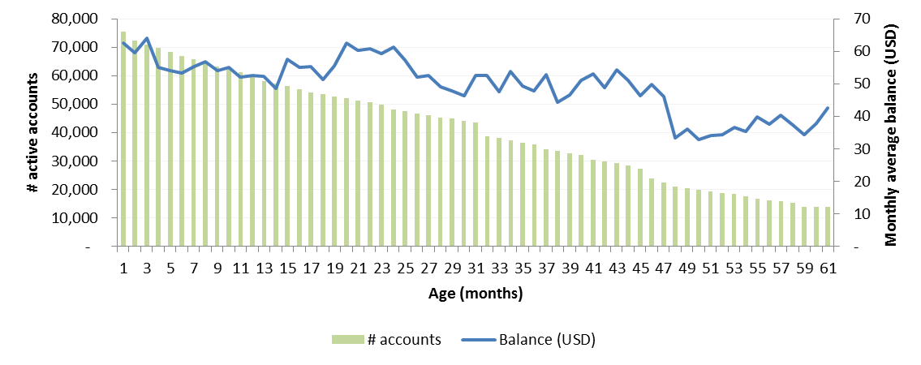

Consequently, to overcome the distortions of quantitative easing, attrition of active accounts is used as a proxy for attrition of deposit balances. This argument is later justified in Assumption Validity under the Testing the Model section.

For SA/NV, we also examined the correlation between the number of active accounts and the average balances, and we found the correlation to be high. The following charts show the deposit balances versus the number of active accounts for SA/NV by product and currency type:





Table 4: Correlation between Balances and Number of Active Accounts



In computing attrition, active accounts are segmented by product. Within each product, accounts are stratified into 240 age buckets. Decay rates are calculated by considering the month over month attrition in number of active accounts by age and product.

The below table presents the different steps of the approach:

Figure 2 Decay Rate Calculation Steps



Steps 1 to 3 are described hereafter.

Step 1: Computation of the month over month decay rate (DR) by age bucket across the historical horizon

The month over month decay rate is computed for each age bucket *i* and each of the 59 months of observation *j* as follows, excluding the last 3 months of the data set per definition 1:

$$DR\left(i,j\right)= \frac{Number of accounts of {age}_{i} in {month}_{j} , closed in {month}_{j+1}}{Number of accounts of age i, active in {month}_{j} -Censored accounts in {month}_{j+1} },$$

$$where i=1,…,240 and j=1,…,58$$

This provides a distribution of DR by age over the modeling period.

Step 2: Computation of an average decay rate by age (Y)

The arithmetic average of the decay rate over the historical horizon is computed by age. The arithmetic average is chosen because decay rates across the observation period in each age bucket are independent.

$$Y_{i}=\frac{1}{58}\sum_{j=1}^{58}{{DR}_{j}} , where i=1,…,240$$

This provides a single decay rate by age.

The following chart compares the mean versus the median of the runoff speeds for BNY Mellon SA/NV:

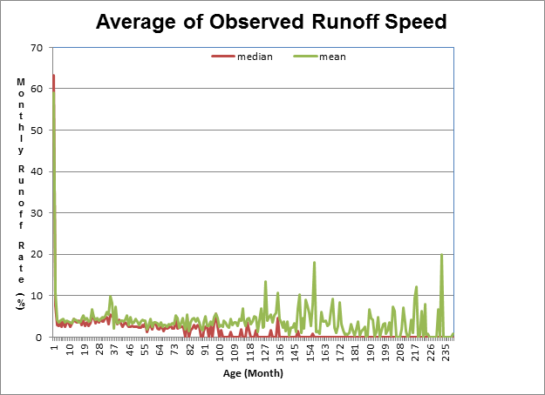

Step 3: Smoothing of the decay rate by age (Z)

In order to reduce the volatility that can exist in the average decay rate Y, a stepwise geometric average function is then applied to the survival rate (1-Y) over defined time periods. The time periods cover multiple age buckets, the older the age buckets, the wider the time period.

The time periods are defined as below:

- Age buckets between 0 and 2 years: constant geometric average over 3 months

- Age buckets between 2 and 5 years: constant geometric average over 6 months

- Age buckets between 5 and 20 years: constant geometric average over 12 months

The smoothed average decay rate, called “Z”, for each age bucket *i* is computed as:

$$Z_{i}=1-{\left(\prod_{j=A}^{B}{\left(1-Y_{j}\right)}\right)}^{\frac{1}{n}}$$

Where n is the number of age buckets included in each time period, and A and B are the boundaries of each time period as defined below:

|  |  |  |  |
| --- | --- | --- | --- |
| **i** | **n** | **A** | **B** |
| $$[1,8]$$ | 3 | n*(i-1)+1 | n*i |
| $$[9,14]$$ | 6 | n*(i-5)+1 | n*(i-4) |
| $$[15,29]$$ | 12 | n*(i-10)+1 | n*(i-9) |

When a decay rate is not available (“NA”), this occurs when there is no account for a given age bucket and given product, the arithmetic average of the decay rates over the previous 3 age buckets is used as a proxy.

Step 4: Application of the decay rate function to derive the balance runoff function

The balance runoff is calculated in QRM by using a Prepayment & Volume function called ‘Dep Study – GeoMean Runoff’. This function derives the runoff based on:

* Operational Deposits (based on the dimension field called “Operational Deposit Class USLCR”) are segmented into :
  + Core Balance which corresponds to the operational balance determined by the Operational Deposit Model. It considered stable but is nevertheless considered to runoff at the decay rates based on the deposit age.

*Core balance (age) = (1 – Decay rate (age)) * Core balance (age-1)*

* + Non-Core Balance which is the excess balance determined by the Operational Deposit Model. It is assumed to runoff at 100% overnight.
* Non-Operational Deposits are also segmented into:
  + Core Balance is assumed to be the lowest average balance of the modeling timeframe, i.e. August 2009 average balance as we do not have a full economic cycle to identify the core. i.e. stable level of balance.

Non-operational Core Balance is assumed to runoff at the same decay rate as Operational Core Balance (identical equation as shown above).

* + Non-Core Balance represents the excess non-operational deposit over Core Balance. It is assumed to runoff at a 100% overnight.
* Truncation of deposits valuation horizon: 100% runoff is set at 120 months into the valuation.

##### **Data for Model Development**

###### **Data Sources**

**Description**

In order to build a reliable model, the modeling exercise requires at least five years of historical daily data at the account level. ALMIS, the main database used for ALM purposes which is reconciled to the Bank’s Books and Records, provides daily data since December 2013. As such, this modeling exercise had to rely on another database as well, the Brussels Warehouse (“BWH”) which has been collecting data from source systems for a longer time period.

ALMIS provides position data from 9 deposits source systems from within the Bank of New York Mellon. Data is extracted from source systems, transformed to correlate, cleanse, and consolidate, and is finally published in QRM environment for reporting and analysis.

BWH provides daily data from as far back as 2002 for some source systems. Data is also collected from the Bank of New York Mellon’s source systems. However the balances are not directly reconciled to the Bank’s books and records and require some cleansing prior to being used for modeling.

The steps undergone to prepare the data set are detailed in subsequent sections of this document.

For the SA/NV model, there are discrepancies when filtering the BWH data by legal entity. Due to the data limitations, the SA/NV model is developed with only ALMIS data. Despite using only two years of data, the SA/NV decay rates are much higher and more conservative than using the full five year dataset.

**ALMIS and BWH Availability and Constraints**

Deposit data is collected from nine source systems. Some source systems data is available in both ALMIS and BWH, whereas for others data is only available in ALMIS. The earliest date for which each source system data is available in each database is detailed below.

Figure 3 Matching Source Systems and Databases

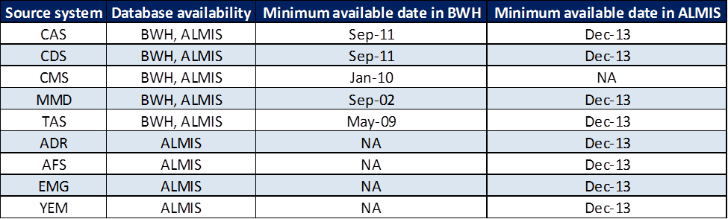

For the purposes of this model, data was collected starting as of January 2010.

**Data Availability by QRM Account**

Deposits at Bank of New York Mellon are segmented in two fashions:

* By deposit product type called ALM account short name as classified in ALMIS
* By deposit product type called QRM account as classified in QRM

Source systems for each QRM account along with data availability in BWH and ALMIS are detailed below:

Figure 4 Matching Account Types, Source Systems, and Databases

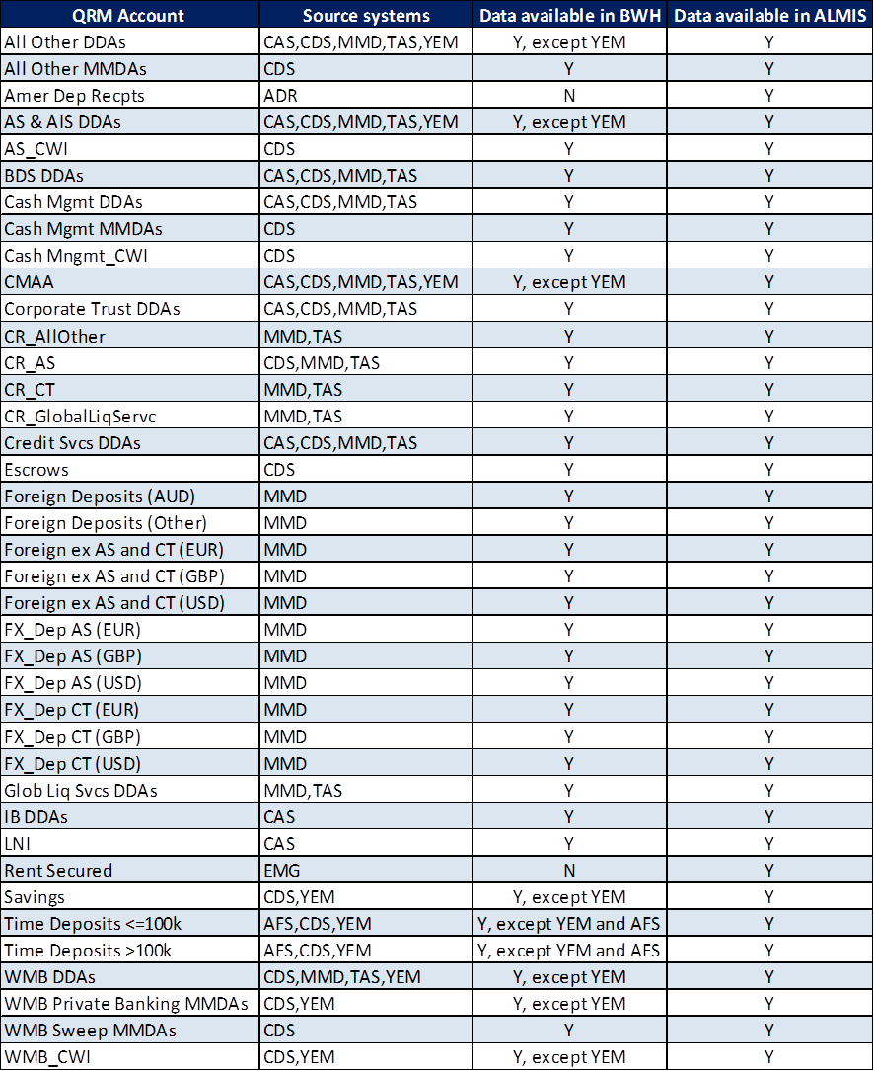

###### **Data Collection**

**Extraction Process**

As noted above, this model uses daily deposits data over a five year horizon at the account level. Due to data availability, BWH data is used from January 2010 to November 2013, and ALMIS data is used from December 2013 to January 2015. Monthly average balances and attributes at account level are extracted for all deposits, except internal deposits and deposits from BLL source from January 2010 to January 2015.

Monthly average balances are computed based on daily end of day balances at account level. The attributes are either directly extracted from the database when available or the results of some tagging logic to attribute core data when not directly available. The list of attributes available in each database and extracted is listed below:

Figure 5 Data Attribute Names and Availability in Databases

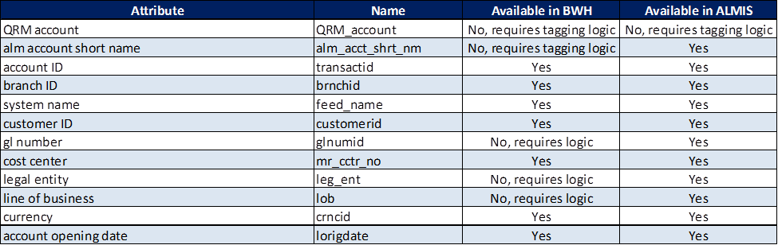

Due to the large amount of data handled for this study, data from BWH is stored into the “Data Lake”. It is a large storage repository that holds data in its native format and is stored using Hadoop. Hadoop implements a scalable parallel processing framework to process large amounts of data in a tractable way.

The data extraction exercise is a two-step process:

1. Data is extracted from BWH and loaded into the Data Lake via HQL queries. These queries can be found in Appendix A of this documentation.

2. ALMIS data is extracted and imported into R-Studio for modeling.

BNY Mellon SA/NV is made up of seven legal entities: 00528, 00539, 00870, 00520, 00521, 00522 and 00523. Legal entity is available in the ALMIS data but not in BWH. To extract BNY Mellon SA/NV-specific data, we filtered on all of the cost centers associated with the SA/NV legal entities, as each cost center has a unique entity. There are 1149 cost centers for SA/NV.

**Data Validation**

Prior to moving the data from BWH to the Data Lake, an overall data validation was performed as part of a previous modeling exercise to ensure that the end of day balance on a given day for a given list of accounts from BWH matched the end of day balance from ALMIS, which is reconciled with the General Ledger on a monthly basis.

###### **BWH Data Preparation for Modeling**

After data has been extracted and stored into the lake, deposit data is prepared for modeling.

**Data Compilation in Hive**

BWH data being very large, the data set is compiled by source system prior to being formatted into hdfs for import into R-Studio. The formatting is performed as below:

* Any BWH account that contains a zero balance over the 5 year horizon is removed from the data set.
* Unique account identifiers are created, defined as below:

*Accounts from IMMS (“MMD”), acctkey = transactid – brnchid – feedname*

*Other accounts, acctkey = transactid – feedname*

* After the unique identifier is created, data is pivoted based on this account identifier in order to have one account per row with all the balances in columns. The migration from TAS to IMMS is accounted for in the pivoting.

HQL scripts for the above steps are provided in Appendix A.

Finally data is loaded into R-Studio working directory.

**BWH Data Attributed in R**

As mentioned earlier, BWH data comes from the source systems directly and therefore underwent less cleansing then ALMIS data. Also BWH does not hold some attributes that are available in ALMIS. Therefore some tagging logic needs to be applied to BWH data in order to have the same list of attributes as in ALMIS prior to merging the two data sets. The schema for data attribution process is summarized below:



Once data is cleaned, accounts have to be segmented as they are expected to behave differently depending on the business they are attached to and / or the class of deposits they belong to. There are potentially three levels of segmentation: line of business level, ALM account short name level and / or QRM account name level.

1. Line of business: BWH accounts are tagged with the line of business and legal entity (legal entity to be used for the ALM account short name tagging logic thereafter) based on the cost center, line of business and legal entity mapping from DRM table.
2. ALM account short name: BWH accounts are tagged with the ALM account short name using the ALMIS tagging logic laid out in document attached to the appendix of this documentation.
3. QRM account: the tagging logic for the QRM account requires some attributes that are not available in BWH, only in ALMIS and for which it would be very complex to recreate the tagging logic based on available BWH data. However, the ALM account short name is very close to the QRM account segmentation and acts as a good proxy for the QRM deposit segmentation.

**BWH to ALMIS Mapping in R**

Once data is cleaned and segmented, BWH and ALMIS data sets are combined to create a 5 years of historical average balance time series at the account level. In order to do so, both data sets have been pivoted based on the key account identifier. Both data sets are therefore merged in R with accounts being mapped based on this account identifier.

The data is also filtered on cost center in order to run the R code on BNY Mellon SA/NV-specific historical data.

From December 2013 to January 2015, there is an overlap of BWH and ALMIS accounts.

**Final Data Set for Modeling**

The final data set that is used for modeling contains BWH accounts from January 2010 to January 2015 and ALMIS accounts from December 2013 to January 2015:

* Instances where individual data points are in BWH and ALMIS, BWH balances are used from January 2010 to November 2013, and ALMIS balances from December 2013 to January 2015.
* Instances where accounts are in BWH but not in ALMIS during overlapping period are tagged with bwh_not_in_almis equal to 1
* Instances where an MMD account has a NULL branch ID are tagged with mmd_ null_br equal to 1
* Finally, accounts that are in ALMIS, but not in BWH are tagged with almis_only equal to 1.

The data set has additional tags to be used for modeling assumptions / censored data set:

* Tag zero_bal_6m identifies accounts with a zero balance over the last 6 months
* Tag cst_bal_6m identifies accounts with a constant balance over the last 6 months

#### **Repricing Function**

##### **Assumptions**

Assumption 1: A model based on regressing changes in product rate over changes in driver rate is preferred. For cases where model did not offer a sufficiently high R2 to accept, regressing rate levels (instead of changes in rates) is considered. The relationship between absolute customer deposit rates and absolute market rates is stronger than the relationship between changes in these rates, as illustrated by higher R2 when regressing levels instead of changes. As residuals of level on level regressions often show non-stationarity, models that regress changes in driver rates on changes in customer rates (first differences) are preferred, assuming a sufficiently high R2.

Models that regress levels on levels then may be used, but only if residuals are stationary per an Augmented Dickey Fuller Test.

Models regressing changes in spread (customer rate – market rate) against changes in market rate can then be considered if neither changes nor levels offer sufficient quality fit.

Assumption 2: The data used to derive the beta for deposits in USD is from a rising interest rate period (2004-2007) is preferred to data from the wider period up to 2015 because the current economic environment is strengthening and the market expectation is that the Fed will hike rates later this year. Unfortunately, most products lack historical data from the rising rate period: for these products, rates from the entire period will be used in the regression instead. For those products with rates from rising period, if fits are not sufficiently good, then entire period is used instead.

Assumption 3: Where a model can’t be sourced for a product from regressions due to insufficient fit, another products regression based model is used to proxy for the behavior of the hard to model product. All product rates are correlated over the recent period, and then the product with a model with the highest correlation to the product which can’t be fit is designated as the proxy.

Assumption 4: Deposits tracking the overnight rate are considered 100% interest rate sensitive and non-interest bearing deposits (like DDAs) have zero interest rate sensitivity.

##### **Formulation**

Application of diverse models into QRM:

Although the 3 types of regression take different functional forms, when converting them back to use current Product Rate (Pt) as a function of previous Product rate (Pt-1), they all converge on an equivalent, based on change in driver Rate (Rt-Rt-1). This assures that even when the current rate (Pt) is not exactly predicted by regression (ε <>0), Pt+1 will still apply Beta consistently given a shock. Note for spread based models (type 3), these essentially use (1+β).

Pt =β*(Rt-Rt-1)+ Pt-1

Proof:

**Change on change**

Pt - Pt-1 = β*(Rt-Rt-1) + ε

Assume ε -> 0

Pt= β*(Rt-Rt-1)+ Pt-1

**Level on level**

Pt=α+ β*Rt + ε

Assume ε -> 0

Then

Pt - Pt-1 =(α+ β*Rt )–(α+ β*Rt-1)

Pt= β*(Rt-Rt-1)+ Pt-1

**Change in driver on Change in spread**

(Pt-Rt) - (Pt-1-Rt-1) = β*(Rt-Rt-1) + ε

Assume ε -> 0

Pt-Rt = β*(Rt-Rt-1) + (Pt-1-Rt-1)

Pt = β*(Rt-Rt-1) + (Pt-1-Rt-1) + Rt

Pt = β*(Rt-Rt-1) + Pt-1 + Rt - Rt-1

Pt = (1+ β)*(Rt-Rt-1) + Pt-1

Pt = (1+β)*(Rt-Rt-1) + Pt-1

Details are presented in Assumption Validity section for Assumption 1.

Interest expenses paid to deposits are used to calculate customer deposit rates.

$$Customer Deposit Rate=\frac{Monthly Interest Expenses }{Average Monthly Deposit Balances*\frac{number of days in the month}{365}}$$

Short-term interest rates considered in this study are the major indices: Fed Funds Effective Rate for USD deposits and Euro Overnight Index Average (EONIA) for EUR deposits and Sterling Overnight Index Average (SONIA) for GBP deposits. Bank of England Base rate was also considered for the GBP Asset servicing

Deposit data is segmented by micro product, defined as a combination of product and line of business, for the purposes of interest rate sensitivity analysis.

The historical timeframe for deposits in USD is split in three distinct periods, based on observed Fed Funds Effective Rates regimes:

* From January 2004 to July 2007: a rising rate environment
* From August 2007 to December 2008: a decreasing rate environment
* From January 2009 to May 2015: a stable rate environment

Figure 6 Trends of Fed Funds Effective Rate from January 2004 to January 2015

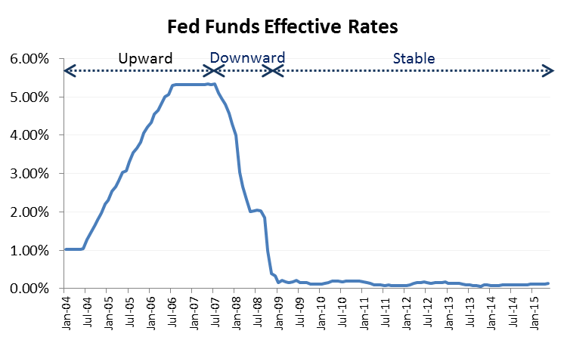

For EUR and GBP deposits, since the historical data is not available prior to 2007, and considering the timing of financial crisis in Europe was different from that in the US, the timeframe of January 2009 to May 2015 was used without segmentation.

For each product, nominal customer rates are regressed against the respective nominal short term rates over a selected period through Data Analysis Regression in Excel.

Only given a complete sample (across up, down and flat rate periods), were 2 models offering sufficiently good fit, as highlighted below.

|  |  |  |  |  |  |  |  |
| --- | --- | --- | --- | --- | --- | --- | --- |
| **Deposit Product** | **R2** | **Beta** | **P-Value** | **P-Value of Beta** | **Acceptable R2** |  | |
| AIS Cash Reserve | 0.05 | -0.70 | 0.06 | No | No |  | |
| Asset Servicing Cash Reserve | 0.50 | 0.49 | 0.00 | Yes | No |  | |
| Asset Servicing CWI (CIBC) | 0.53 | 0.33 | 0.00 | Yes | No |  | |
| Asset Servicing USD | 0.25 | 0.14 | 0.00 | Yes | No |  | |
| Cash Mgmt CWIs | 0.07 | 0.15 | 0.00 | Yes | No |  | |
| Cash Mgmt MMDAs | 0.07 | 0.69 | 0.00 | Yes | No |  | |
| Corp Trust Cash Reserve | 0.56 | 0.48 | 0.00 | Yes | Yes |  | |
| Glob Liq Svcs Cash Reserve | 0.00 | -0.08 | 0.62 | No | No |  | |
| LNI | 0.82 | 0.76 | 0.00 | Yes | Yes |  | |
| Total Corporate Trust USD | 0.43 | 0.59 | 0.00 | Yes | No |  | |
| WMB CWIs | 0.01 | 0.03 | 0.38 | No | No |  | |
| WMB Private Banking MMDAs | 0.01 | 0.66 | 0.38 | No | No |  | |
| WMB Savings* | 0.44 | 0.49 | 0.00 | Yes | No |  | |
| WMB Sweep MMDAs | 0.07 | 0.63 | 0.00 | Yes | No |  | |
| Asset Servicing EUR | 0.33 | 0.61 | 0.00 | Yes | No |
| Asset Servicing GBP | 0.14 | 0.40 | 0.00 | Yes | No |
| Total Corporate Trust EUR | 0.75 | 0.62 | 0.00 | Yes | Yes |
| Total Corporate Trust GBP | 0.33 | 0.20 | 0.00 | Yes | No |
|  |  |  |  |  |  | |  |

Once a product’s rates have a satisfactory model, it is removed from the table, e.g. LNI does not appear again in summary tables.

Moving on to regressing rate levels (instead of changes in rates), more models shows sufficiently high R2. Where possible, upward rate environment (July 04-07) were preferred over full sample period; for most products however rate data was only available for the period after 2007.

Of the 8 products with rate histories including the upward rate period, only 2 offered regression with sufficiently high R2 and non-stationary residuals

|  |  |  |  |  |  |  |
| --- | --- | --- | --- | --- | --- | --- |
| **Deposit Product** | **R2** | **Beta** | **P-Value of Beta** | **P-Value Sig?** | **Acceptable R2** | **Residuals stationary (lag, confidence)** |
| Asset Servicing Cash Reserve | 0.99 | 0.52 | 0.00 | Yes | Yes | No |
| Asset Servicing CWI (CIBC) | 0.97 | 0.40 | 0.00 | Yes | Yes | No |
| Cash Mgmt CWIs | 0.95 | 0.27 | 0.00 | Yes | Yes | No |
| Cash Mgmt MMDAs | 0.98 | 0.92 | 0.01 | Yes | Yes | No |
| Corp Trust Cash Reserve | 0.97 | 0.55 | 0.00 | Yes | Yes | No |
| WMB CWIs | 0.44 | -.06 | 0.00 | Yes | No | No |
| WMB Private Banking MMDAs | 0.94 | 0.75 | 0.00 | Yes | Yes | Yes (5, 90%) |
| WMB Sweep MMDAs | 0.99 | 0.96 | 0.00 | Yes | Yes | Yes (3, 95%) |

More models had rates from the recent period, which may have only included decreasing or flat rate regimes.

Any level on level models with non-stationary residuals were then rejected.

|  |  |  |  |  |  |  |
| --- | --- | --- | --- | --- | --- | --- |
| **Deposit Product** | **R2** | **Beta** | **P-Value of Beta** | **P-Value Sig?** | **Acceptable R2** | **Residuals stationary (lag, confidence)** |
| AIS Cash Reserve | 0.00 | -0.0969 | 0.02 | Yes | No | No |
| Asset Servicing Cash Reserve | 0.99 | 0.5105 | 0.00 | Yes | Yes | Yes (1, 95%) |
| Asset Servicing CWI (CIBC) | 0.97 | 0.3106 | 0 | Yes | Yes | Yes (1, 95%) |
| Asset Servicing USD | 0.86 | 0.3823 | 0.00 | Yes | Yes | Yes (1, 95%) |
| Cash Mgmt CWIs | 0.95 | 0.2856 | 0.00 | Yes | Yes | Yes (1, 95%) |
| Cash Mgmt MMDAs | 0.98 | 0.8693 | 0.01 | Yes | Yes | No |
| Corp Trust Cash Reserve | 0.97 | 0.5208 | 0.00 | Yes | Yes | Yes (4, 95%) |
| Glob Liq Svcs Cash Reserve | 0.66 | 0.3254 | 0.00 | Yes | Yes | Yes (5, 95%) |
| Total Corporate Trust USD | 0.92 | 0.6663 | 0.00 | Yes | Yes | Yes (1, 95%) |
| WMB CWIs | 0.64 | 0.1576 | 0.00 | Yes | Yes | No |
| WMB Savings | 0.95 | 0.6120 | 0.00 | Yes | Yes | Yes (1, 95%) |
| Asset Servicing GBP* | 0.57 | 0.569 | 0.00 | Yes | Yes | Yes (1, 95%) |
| Total Corporate Trust GBP** | 0.89 | 0.20 | 0.00 | Yes | Yes | Yes (1, 95%) |

*model uses UK Base Rate

**model uses SONIA

Models were then tested solving for changes in Spread (base rate + spread = customer rate), based on changes in Driver rate. VIF test proved that dependent and independent variables were not auto correlated. To compare to Betas above, use 1+beta to infer net rate sensitivity (see proof on page 14).

|  |  |  |  |  |  |  |
| --- | --- | --- | --- | --- | --- | --- |
| **Deposit Product** | **R2** | **Beta** | **1+beta** | **P-Value** | **P-Value of Beta** | **Acceptable R2** |
| AIS Cash Reserve | 0.24 | -1.70 | -0.70 | 0.00 | Yes | No |
| Cash Mgmt MMDAs | 0.16 | -0.31 | 0.69 | 0.00 | Yes | No |
| WMB CWIs | 0.89 | -0.97 | 0.03 | 0.00 | Yes | Yes |

For products still lacking sufficiently robust rate models, a correlation analysis was run over the 4 year period to reveal which rates were most similar and could therefore proxy the rate behavior.

|  |  |  |
| --- | --- | --- |
| **Deposit Product** | **Proxied by** | **Correlation** |
| AIS Cash Reserve | WMB Private Bank MMDAs | 88% |
| Cash Mgmt MMDAs | WMB Private Bank MMDAs | 84% |

For SA/NV specifically, historical data is only available from January 2010 through the present. This period creates limitations for developing a statistically sound regression, especially for USD and GBP foreign deposits which had low, flat rates for the entire period. As a result, we performed the regressions using absolute levels and relative changes for:

1. **SA/NV data only from January 2010 through present**
2. **SA/NV data from 2010 through present appended with Holding Company data from before 2010 (as much history as was available for the BHC model)**

**The resulting betas, R2, and p-values for each of the iterations for SA/NV are summarized below:**



**The SA/NV data was not available by line of business, so the BHC data is a weighted average of the Asset Servicing and Corporate trust rates from the Holding Company dataset. As of December 2015, 93% of the deposits balance is Asset Servicing and 7% is Corporate Trust.**

**As the table above shows, the regressions based on absolute levels using the additional BHC data have the highest statistical significance, and the resulting betas are very close to the Holding Company model. However, based on the data limitations, we are applying a conservative bias and using the higher beta between the SA/NV data only versus the SA/NV data appended with BHC data. Each of the results that are used are highlighted in green.**

**In general, relative changes produced poor results and has been excluded from consideration. The exception is GBP deposits. The SA/NV data by itself produced a 66% R-squared, but the corresponding beta of 9% is unrealistically low. Using the relative changes regression while including BHC data, the beta is much more reasonable and will be used as a result.**



##### **Data for Model Development**

**Actual monthly interest expenses and monthly average balance amounts were extracted from MAQ (Management Accounting System).**

### Input Data and Data Assumptions

#### **Runoff Function**

The current data set for this model is based on the time horizon January 2010 – February 2015, and going forward the new monthly data will be augmented to the current data set. The new monthly average balance data will be fed from ALMIS to this model, along with the data fields below. QRM account will be generated by tagging logic and added to the data set.

|  |  |
| --- | --- |
| **Attribute** | **Available in ALMIS** |
| QRM account | No, tagging logic should be used |
| alm account short name | Yes |
| account ID | Yes |
| branch ID | Yes |
| system name | Yes |
| customer ID | Yes |
| gl number | Yes |
| cost center | Yes |
| legal entity | Yes |
| line of business | Yes |
| currency | Yes |
| account opening date | Yes |

The Operational Deposit Model #2458 will provide the core/non-core balances of operational deposit to this model. The output from this model - decay rates for each age bucket and product type - will be fed into the EVE and NII model (#2359) on the QRM platform to calculate EVE baseline and sensitivity.

#### **Repricing Function**

##### **Data Source**

**MAQ (Management Accounting System) will provide actual monthly interest expenses and monthly average balance amounts, except for Asset Servicing CWI (CIBC) for which information is received directly for the line of business twice a year in May and November.**

**SA/NV deposit expense and average balance was provided by SA/NV Finance for history. This can be obtained from MAQ going forward.**

### Model Impact to Current Valuation and EVE Sensitivity

As mentioned in the Purpose and Use section, the balance runoff function and the deposit beta are components of the valuation model for non-maturity deposits.

Currently the QRM platform which conducts valuation is configured to force 100% runoff of all deposit after 120 months of projection. This is consistent with industry practice, per Quaglieriello’s *Stress Testing the Banking System,* (p. 155), as published by Cambridge University Press in 2009.

To qualify the truncation point, a test based on June 2015 month end data was conducted as below. It shows that a period of projection longer than 120 months does not have a significant impact on deposit duration. Therefore 120 months is chosen as the truncation point.

|  |  |  |
| --- | --- | --- |
| **Valuation Truncation Period** | **Duration** | **Impact on Duration** |
| 120M | 1.04 | Base case |
| 60M | 0.92 | -11.5% |
| 240M | 1.06 | 1.9% |

Based on June 2015 month end data, the overall impact of the new deposit valuation model is an increase in deposits duration, from 0.91 to 1.04 as shown in the deposit valuation table below:

Figure 7 Deposit Valuation



This results in longer liabilities and overall shorter duration of the current balance sheet as shown in the IRR EVE Sensitivity report below.

Figure 11 Impact of the new model in the IRR EVE Sensitivity report



Using March 31, 2016 BNY Mellon SA/NV portfolio, valuation analysis was run with the Holding Company decay rates and non-core assumptions as well as with the SA/NV-tuned decay rates and non-core percentages. The results are very similar, as shown in the table below:



Durations are much lower in the SA/NV model because the decay rates are much more conservative.

## Testing the Model

### Model Outputs

#### **Runoff Function**

The graph below represents the decay rate function for each deposit product from the original Holding Company model.

Figure 8 Decay rate function per product

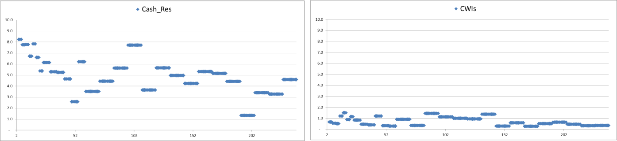

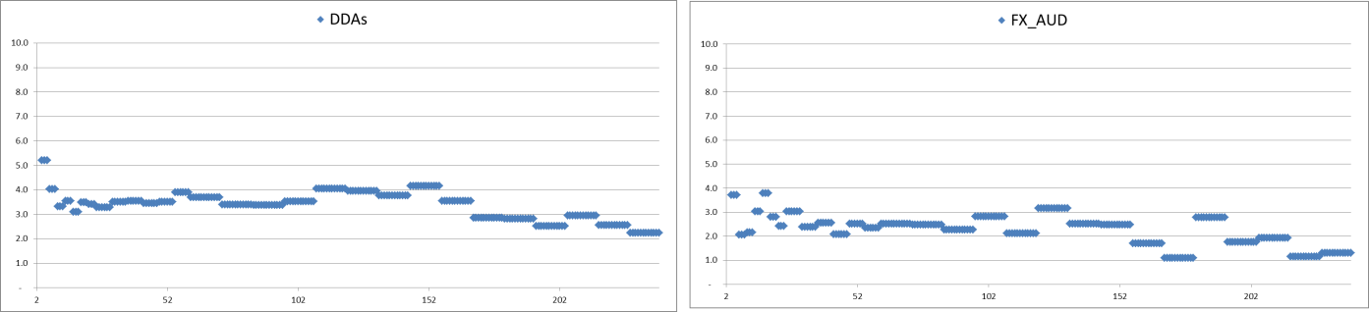

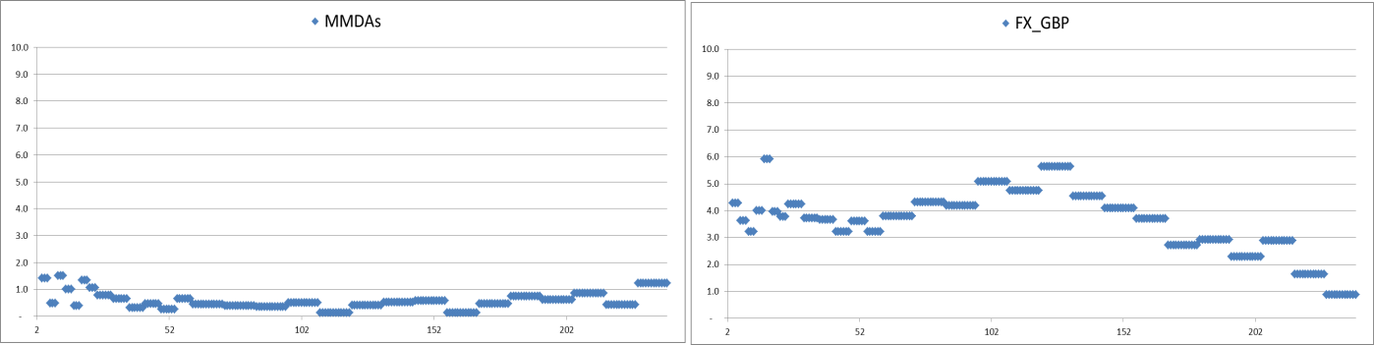

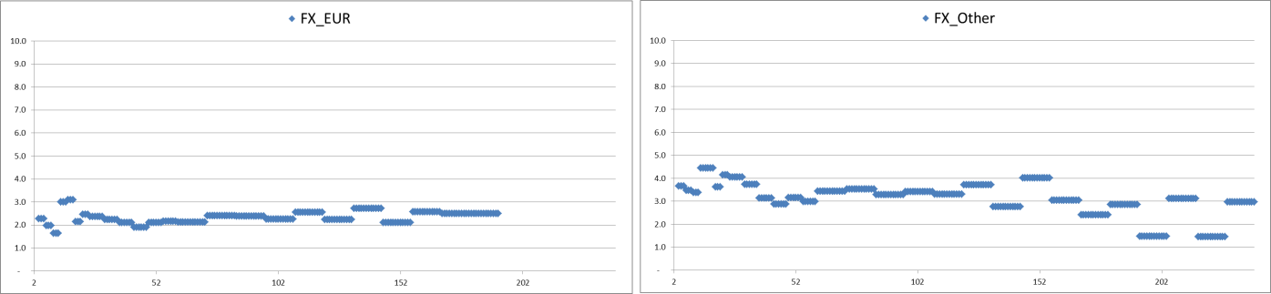

The following graphs show the decay rate function for the SA/NV model compared to the Holding Company model (“Old label”):



**Any deposit older than 240 months is assumed to decay at the same rate as the 240th age bucket. The decay rate vector for each product is attached.**



The decay rates are then plugged in QRM using a multidimensional table called ‘Deposits Decay Rate Vectors’. The two dimension of the table are the product and the age bucket. This table is looked up dynamically by the ‘Prepayment & Volume function’ in QRM. Thus the Prepayment & Volume function pulls the decay rate for each product at the respective deposit age and applies it in the valuation. The non-core percentage (excess balance percentage) for Operational Deposits is plugged in a look-up table in QRM called ‘Deposits_Operational_NonCore’.

The code for the Prepayment & Volume function is provided in the Appendix.

#### **Repricing Function**

The beta sensitivity function is implemented in the product specifications in QRM using the variable rate instrument template. Because the 3 methodologies for regression can be reduced to Pt =β*(Rt-Rt-1) + Pt-1, as page 14 proves, models can be implemented similarly using previous period values.

A rate index is defined for each segment (combination of LoB and deposit product type) in QRM

(Example) Repricing Index for Corporate Treasury FX GBP

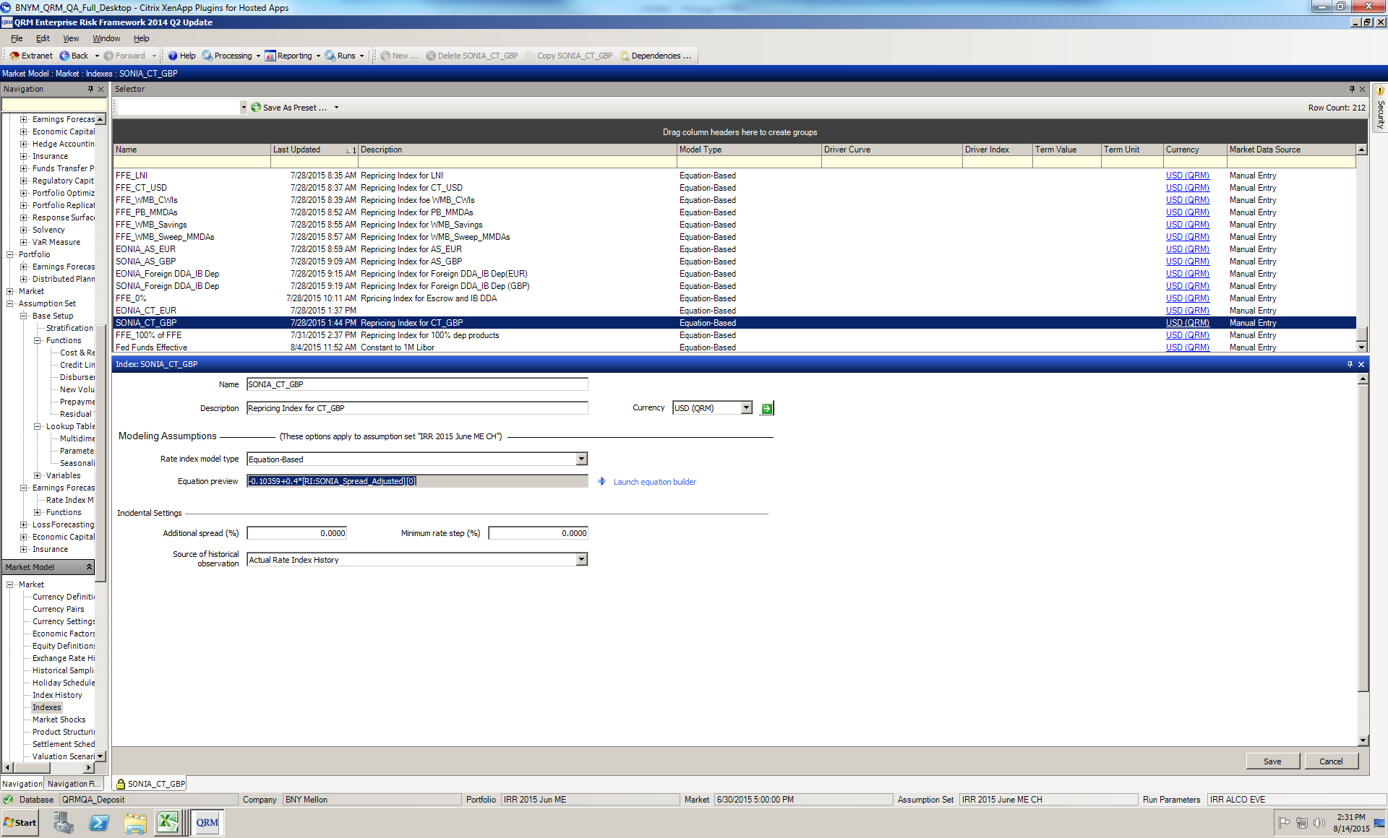

Forecasted deposit rates are derived from the following general equation:

*Forecasted Deposit Rate = (change in Benchmark market rate * Beta) + current Deposit Rate*

The equation is customized for each segment by plugging in the following:

- beta (coefficient) from the regression analysis

- benchmark market rate and previous period product rate

Deposit Rate Beta Sensitivity summary by deposit products is presented below:

|  |  |  |  |  |
| --- | --- | --- | --- | --- |
| **Deposit Product** | **Model type** | **Alpha** | **Beta** | **Driver** |
| AIS Cash Reserve | level on level (up regime) | -0.01 | 0.7470 | FF level |
| Asset Servicing Cash Reserve | level on level | 0.00 | 0.5105 | FF level |
| Asset Servicing CWI (CIBC) | level on level | 0.00 | 0.3106 | FF level |
| Asset Servicing USD | level on level | 0.00 | 0.3823 | FF level |
| Cash Mgmt CWIs | level on level | 0.00 | 0.2855 | change in FF |
| Cash Mgmt MMDAs | level on level (up regime) | -0.01 | 0.7470 | FF level |
| Corp Trust Cash Reserve | level on level | 0.00 | 0.5208 | change in FF |
| Glob Liq Svcs Cash Reserve** | level on level | 0.00 | 0.3254 | change in FF |
| LNI | change on change | 0.00 | 0.7634 | change in FF |
| Total Corporate Trust USD | level on level | 0.00 | 0.6663 | FF level |
| WMB CWIs | change in spread on change in driver | 0.00 | 0.0261 | change in FF |
| WMB Private Banking MMDAs | level on level (up regime) | -0.01 | 0.7470 | FF level |
| WMB Savings | level on level | 0.00 | 0.5815 | FF level |
| WMB Sweep MMDAs | level on level (up regime) | -0.01 | 0.9595 | FF level |
| Asset Servicing EUR | level on level | 0.00 | 0.5397 | EONIA level |
| Asset Servicing GBP | level on level | 0.00 | 0.5693 | change in SONIA, proxy for BOE Base rate |
| Total Corporate Trust EUR | change on change | 0.00 | 0.6228 | EONIA level |
| Total Corporate Trust GBP | level on level | 0.00 | 0.1985 | SONIA level |

### Analysis of the Model

#### **Runoff Function**

##### **Assumption Validity**

1. Assumption 1: The deposit run-off can be approximated by the attrition rate of number of active accounts.

The initial approach considered decay rates based on deposit balances using the same segmentation as the final model by age buckets. The month over month decay rate (DR) from January 2010 to February 2015 was calculated as described below:

$$DR\left(i,j\right)= \frac{Balance of accounts of {age}_{i} in {month}_{j}-Balance of accounts of {age}_{i-1} in {month}_{j-1} }{Balance of accounts of {age}_{i-1} in {month}_{j-1}-Balance of censored accounts}$$

$$where i=2,…,240 and j=2,…,62$$

In Figure 9, each point represents the geometric average decay rate over the historical time period for each age bucket.

Figure 9 Decay rate by age based on the balance of closed accounts

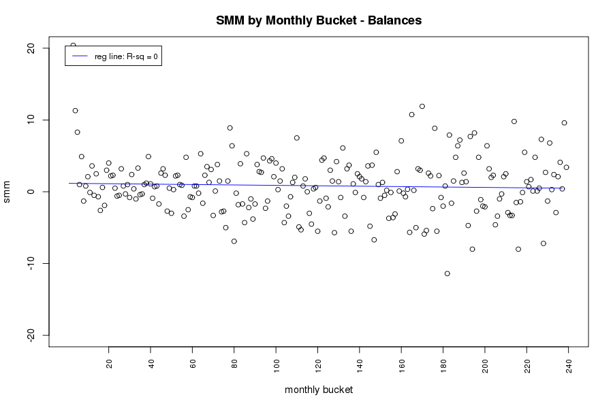

Decay rate (in %)

Age (in months)

The decay rates resulting from this approach were too volatile. One explanation for these weaker results is that the historical data set is limited to the post quantitative easing time period. As explained in the Limitations section and the Overview section, balance trends during this period are not representative of their long term behavior and therefore are poor inputs for estimating balance runoff.

To overcome this modeling constraint, attrition in number of active accounts is used as a proxy for attrition in deposit balances for the following reasons:

(i) It provides less volatile results.

(ii) The evolution of number of accounts over time follows a similar trend as deposit balances.

(iii) Using attrition in number of accounts as a proxy for balance runoff makes the implicit assumption that balance sizes are homogeneous across the deposit pool. However attrition in accounts with low balances is higher relative to accounts with higher balances, which lend a conservative bias to the model.

These points are justified hereafter.

(i) The analytical improvements from using the number of active accounts to calculate decay rates instead of balances are shown below.

1-month decay rate (in %)

Figure 10 Decay rate by age based on the attrition of active accounts

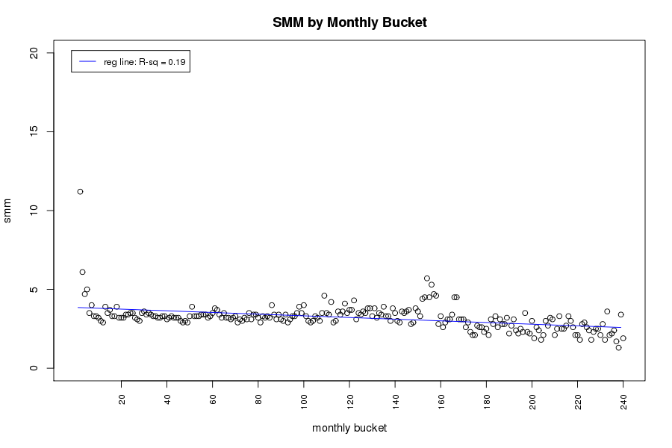

Decay rate (in %)

Age (in months)

(ii) The evolution of number of accounts over time follows a similar trend as deposit balances as shown in the graph below at the aggregated level.

Figure 11 Correlation between number of accounts and balances

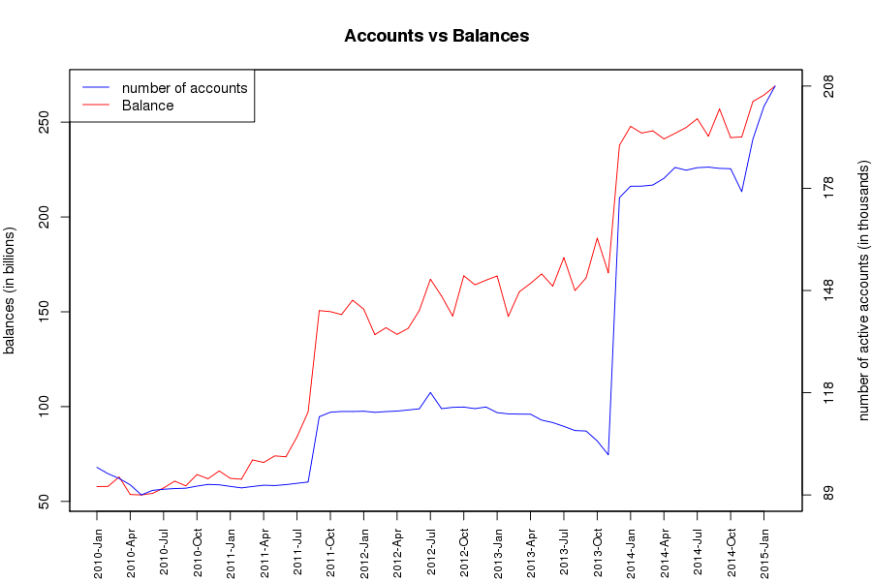

The relationship between balances and number of active accounts holds at the product level as shown below. All the products show a strong positive correlation bigger than 0.6, except Foreign deposits (GBP) which shows a little weaker correlation. Charts in Appendix D illustrate balances and number of active accounts per product type in detail.

Table 1 Correlation between Balances and Number of Active Accounts

|  |  |
| --- | --- |
| **Deposit Type** | **Correlation** |
| Cash Reserves | 0.96 |
| DDAs | 0.93 |
| MMDAs | 0.87 |
| CWIs | 0.96 |
| Foreign deposits (USD) | 0.91 |
| Foreign deposits (AUD) | 0.79 |
| Foreign deposits (EUR) | 0.71 |
| Foreign deposits (GBP) | 0.38 |
| Foreign deposits (Other) | 0.64 |

The table below shows the correlation between balances and active accounts for SA/NV:



(iii) Lastly, using the attrition in number of accounts as a proxy for deposit runoff makes the implicit assumption that balance size is homogeneous across all accounts under a product. However as can be seen in the graphs below, where number of accounts is plotted against time stratified by balance size, the lowest balance size bucket has the highest number of accounts and the lowest total balance versus the highest balance size bucket has the lowest number of accounts but the highest total balance.

Figure 12 Number of accounts by account balance size

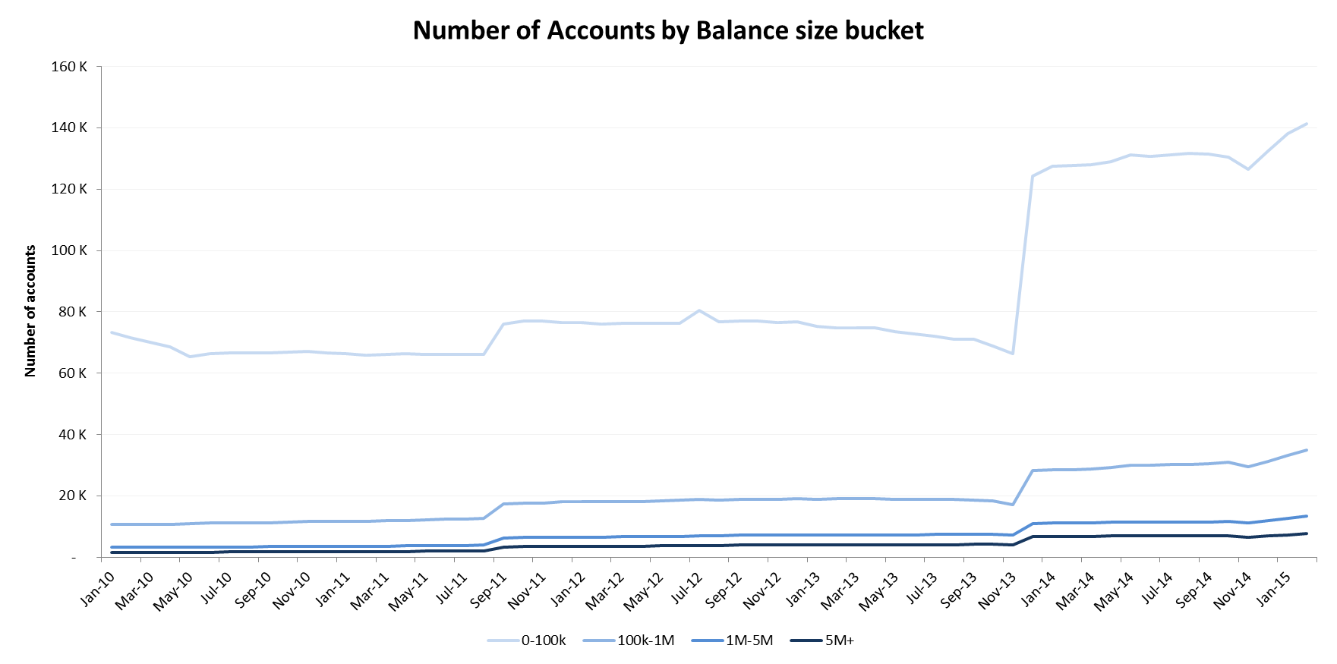

Figure 13 Total balance by account balance size

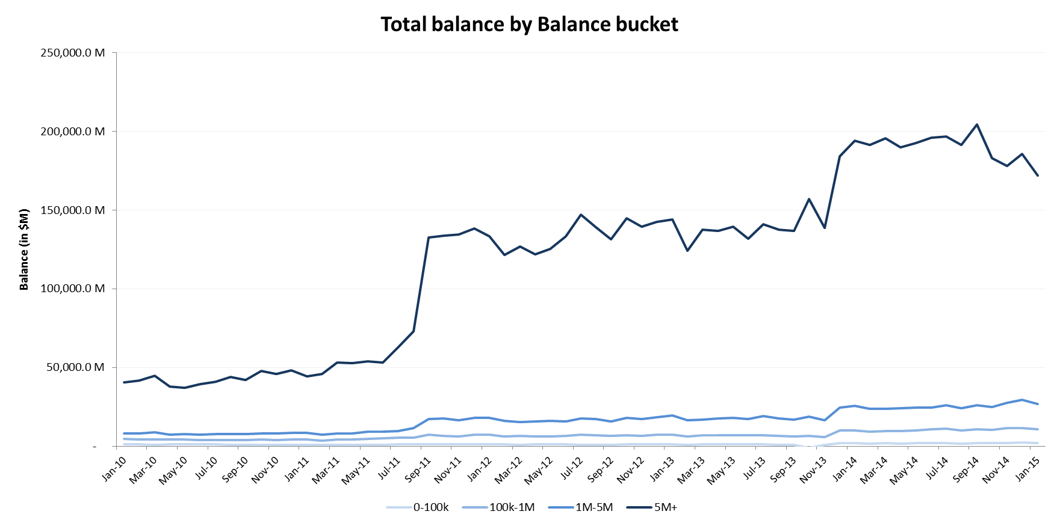

In order to assess the impact of this inhomogeneity in balances, we segmented the deposits by balance size and computed the decay rates for each balance size bucket. We then compared the results with the decay rates without segmenting deposits by their balance size. The results are provided in the graph below.

Figure 14 Decay Rate by balance size buckets

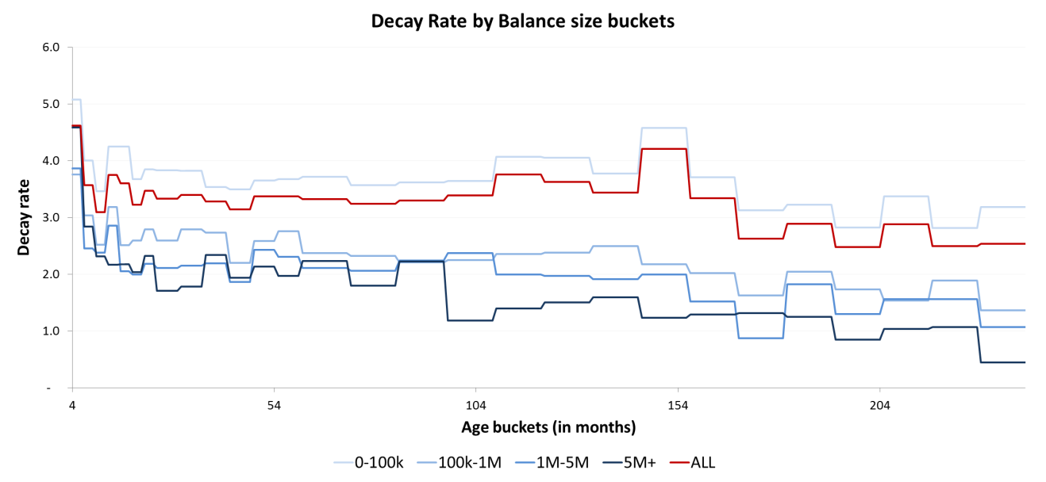

The decay rates when segmenting by balance size are constantly lower than the decay rates when considering all deposits together, except for the accounts with the smallest balances. However, as shown in the previous graph, these deposits account for a small portion of the total balance. The impact of having lower decay rates for small accounts is therefore largely counterbalanced by having higher decay rates for larger accounts.

Using the attrition in number of active accounts as a proxy for balance runoff, i.e. considering that all accounts have similar balance size is therefore an overall conservative approach. It results in higher decay rates and therefore lower duration for deposits.

Based on the above explanations, using the attrition in number of accounts as a proxy for deposit runoff is a reasonable assumption.

1. Assumption 2: The decay function is independent of interest rates.

Interest bearing deposits are priced based on the central bank interest rates (e.g. Fed Funds Target rates). However as shown on the graph below, the interest rates have been stable since 2009 while balances of interest bearing deposits have increased.

Figure 15 Total deposit balances and Fed Fund Target rates since 2009

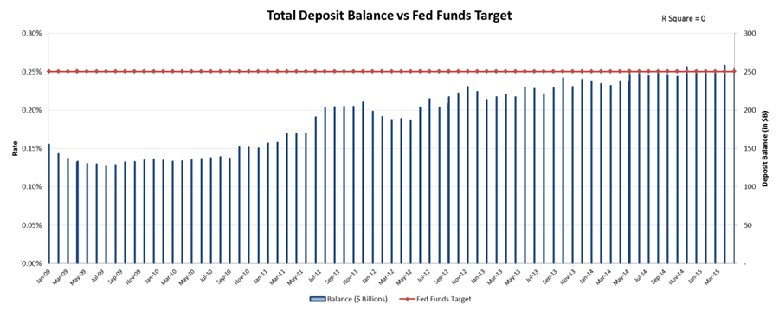

In order to test whether there is any significant relationship with short term interest rates, three dependent variables were regressed against different interest rates:

* Dependent variable 1: total deposit balance over time
* Dependent variable 2: attrition rate observed over time
* Dependent variable 3: total number of active accounts over time (excluding new accounts coming in after the 1st month)

The interest rates considered are: Fed Funds Target rate, Fed Fund Effective rate, repo rate and commercial paper rate (30 days).

The graphs provided below present each variable with the different interest rates considered. The regression results show R-squares between 0.14 and 0.44, leading to the conclusion there is not a significant relationship between those short term interest rates and account attrition metrics over time. Therefore, using the interest rates will not bring any additional value to the decay function.

Figure 16 Total deposit balances vs. short term rates

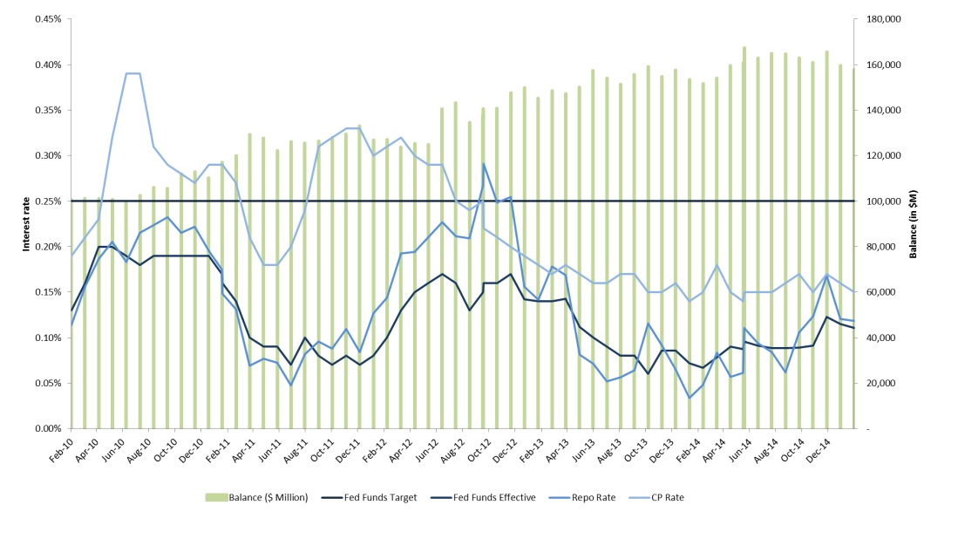

Figure 17 Observed attrition rates vs. short term rates

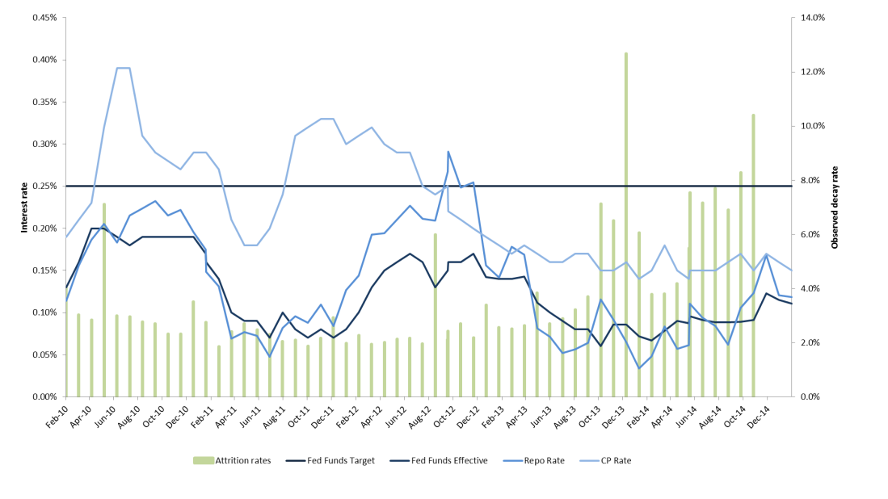

Figure 18 Number of active accounts for cohort January 2010 (excluding all new accounts) vs. short term rates

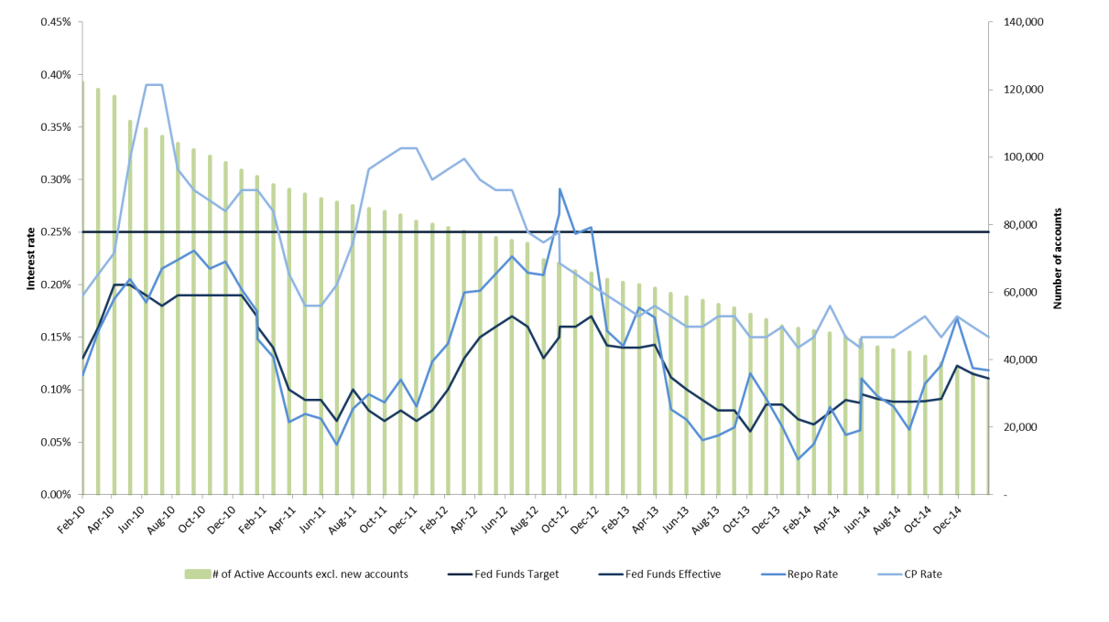

The following chart shows the SA/NV runoff rates versus short term interest rates. As with the BHC data, the SA/NV data shows very low correlation with the interest rates.





1. Assumption 3: BNYM deposits are segmented into nine product categories.

Grouping deposits by product like type creates homogeneous pools of attrition as similar products are expected to behave homogeneously.

A more granular segmentation such as a combination of product and line of business would have produced very thin age buckets with too few accounts to model on. Indeed the distribution of accounts across the different product and line of business is not homogeneous as shown in the spreadsheet ”Number of accounts per month and per product & LOB combination” attached in Appendix D. Some segment would not have had enough accounts to produce a reliable estimate of the decay rate.

Using the line of business as segmentation criteria only does not seem to be appropriate for use in this model as the different deposit products in a line of business are not expected to behave similarly.

1. Assumption 4: Accounts older than 240 months are treated as 240 months old.

This model uses 240 age buckets due to the limitations in our data set where very few accounts populate the age buckets past a certain age as shown on the graph below.

Figure 19 Total number of accounts that have reached each age bucket throughout the entire period

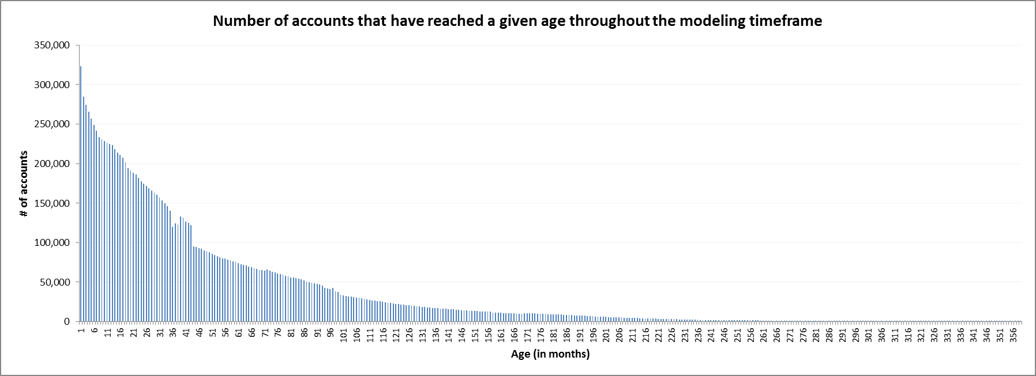

We discovered that the older age buckets do not have enough accounts to compute a reliable decay rate. We consequently assumed all the accounts older than 240 months decay at the same rate as the 240th age bucket.

We tested the sensitivity of our results to this assumption. We calculated the decay rates based on different stratification assumptions: 120 and 360 age buckets. Subsequently we ascertained the number of active accounts per age bucket as of February 2015, and applied the estimated decay rates to the age buckets each month for the next 10 years.

We compared the curves produced by the three stratification assumptions and found no significant difference in the decay as shown in the graphs below. The impact of this assumption on the model output is not materially significant.

Figure 20 Number of active accounts over the next 10 years using 120, 240 and 360 age bucket caps

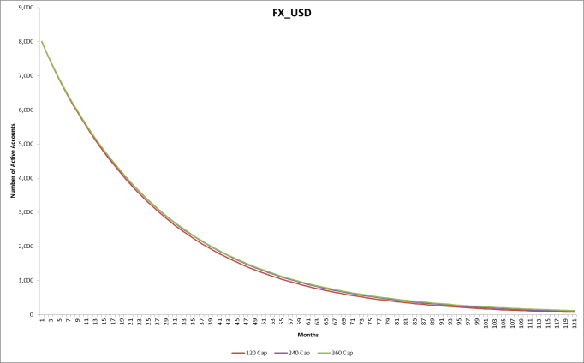 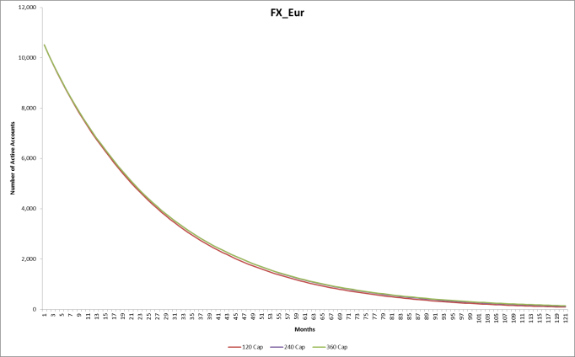

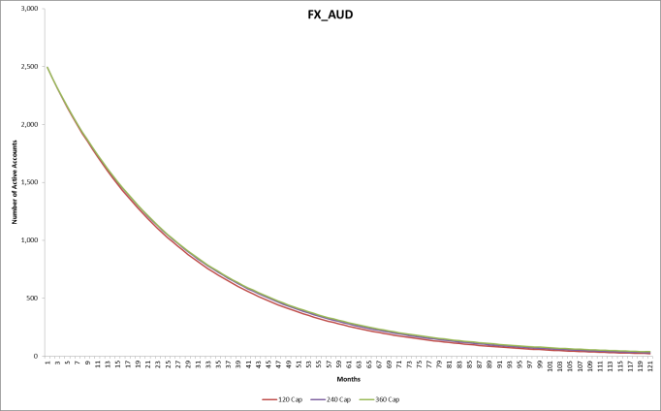 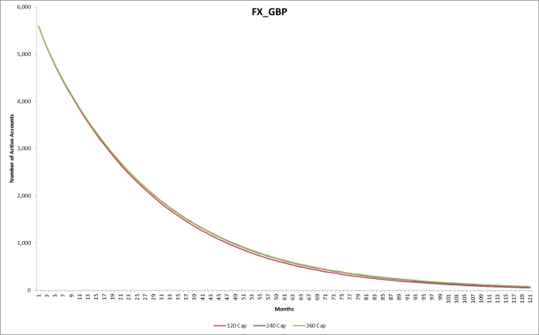

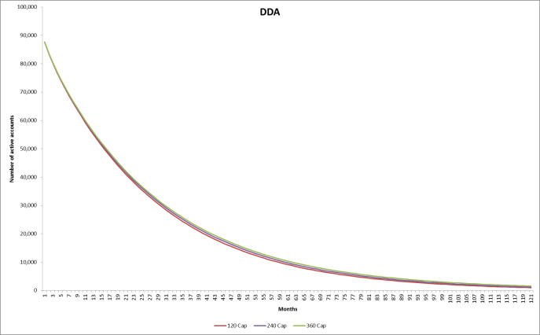 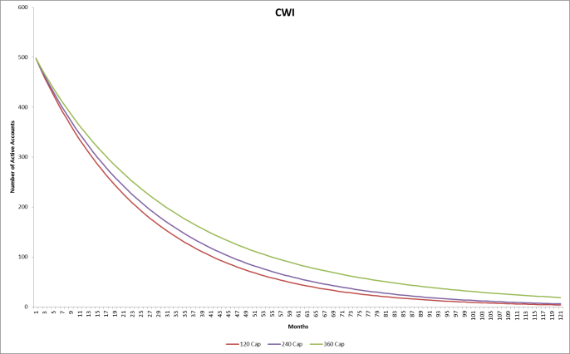

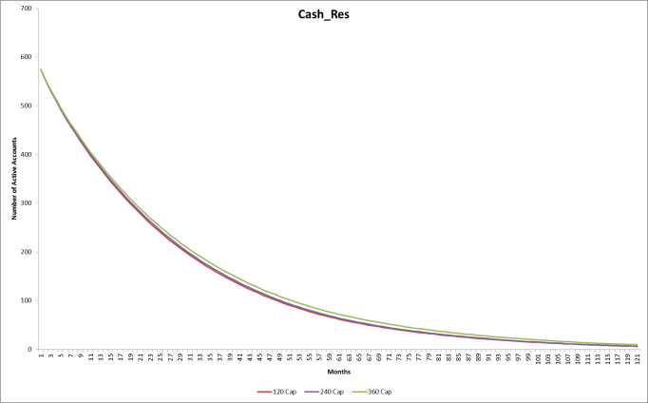 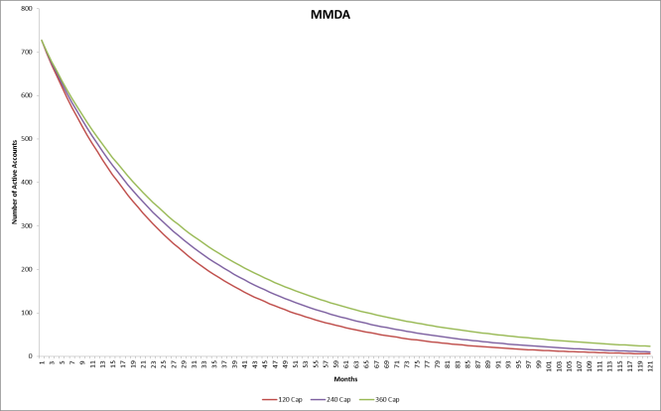

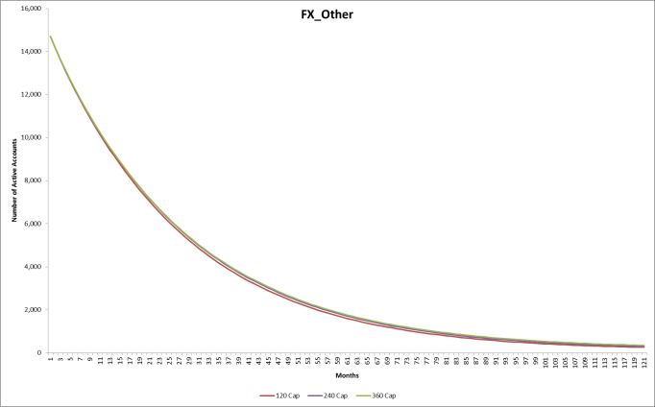

Assumption 5: Deposits are segmented into Operational and Non-operational deposits, each of which is then further segmented into Core/Non-Core balances. Decay rate vectors are applied to the Core balances whereas the Non-Core balances are assumed to runoff at 100% overnight.

Operational deposits are not rate sensitive per the extract of the definition of an operational deposit provided in the U.S. LCR rule: “The deposit account must not be designed to create an economic incentive for the customer to maintain excess funds therein through increased revenue, reduction in fees, or other offered economic incentives”. The complete definition is provided in the Appendix.

Also Core balances for both Operational and Non-Operational deposits are considered as stable balances. It is reasonable to subject them to decay using our decay rate vectors.

The Non-Core balances for Operational deposits, i.e. the excess balance per the Operational Deposit Model, is considered less stable and can runoff in case of a stress event. Assuming 100% runoff for Non-Core balances for Operational deposits is therefore the most conservative assumption we can make.

The behavior of Non-Core balances for Non-Operational deposits is more complex to estimate. As explained in the Limitations section, due to data constraints, we have no information on the rate sensitivity of Non-Core balances of Non-Operational deposits when the rates regime changes. In order to compensate for this model risk, we consider that Non-Core balances runoff at 100% overnight.

We compared our runoff rates with the lines of business forecast runoff used in NII forecasting. The runoff to base scenario balance over a 12-month cycle is smaller than the proposed runoff. As shown below:

|  |  |  |  |
| --- | --- | --- | --- |
| Shock Up 50 | Shock Up 100 | Shock Up 200 | Shock Up 300 |
| 8% | 11% | 18% | 23% |

In our proposed segmentation, 50.1% of the Non-Operational deposits balance runs off at 100% overnight. This leads to an overall higher runoff than that forecasted by businesses. Our forecast is therefore more conservative than the businesses despite the lack of interest rate sensitivity in the runoff function.

##### **Parameters sensitivity**

The sensitivity of the model output, i.e. the deposit duration, to the different parameters of the model is tested below based on June 2015 month end data.

The different parameters tested are:

* Split between the Core and Non-Core balances for Operational deposits,
* Split between the Core and Non-Core balances for Non-Operational deposits,
* Decay rate for the Core balances,
* Runoff time for the Non-Core balances.

1. Core/Non-Core split for Operational deposits

The split between Core/Non-Core deposits for Operational deposits is computed by the Operational Deposit Model. A range of Non-Core percentages for Operational deposits from 0% to 100% were tested to assess the effects of the segmentation on duration.

|  |  |  |
| --- | --- | --- |
| **% of Non-Core Deposit** | **Duration** | **Impact on Duration** |
| Model (base case 31%) | 1.04 | Base case |
| 0% | 1.15 | 11% |
| 100% | 0.39 | -63% |

The same sensitivities were run for the SA/NV model. The results are consistent:

|  |  |  |
| --- | --- | --- |
| **% of Non-Core Deposit** | **Duration** | **Impact on Duration** |
| Model (base case 12%) | 0.59 | Base case |
| 0% | 0.66 | 12% |
| 100% | 0.11 | -81% |

2. Core/Non-Core split for Non-Operational deposits

We assumed the lowest balance level of deposits in 2009 to represent the Core balance of Non-Operational deposits in our model. We tested a range of Non-Core percentages for Non-Operational from 0% to 100% to assess its effect on duration.

|  |  |  |
| --- | --- | --- |
| **% of Non-Core Deposit** | **Duration** | **Impact on Duration** |
| Model (base case 50%) | 1.04 | Base case |
| 0% | 1.42 | 37% |
| 100% | 0.66 | -37% |

For SA/NV non-operational excess, we ran the same sensitivities:

|  |  |  |
| --- | --- | --- |
| **% of Non-Core Deposit** | **Duration** | **Impact on Duration** |
| Model (base case 50%) | 0.59 | Base case |
| 0% | 0.70 | 18% |
| 100% | 0.48 | -19% |

3. Decay rate

To test the sensitivity of the model to decay rates, the decay rates were increased by a range of multipliers. Decay rates per each deposit type and age for this scenario test are presented in Appendix F.

|  |  |  |
| --- | --- | --- |
| **Multipliers** | **Duration** | **Impact on Duration** |
| 1 (base case) | 1.04 | Base case |
| 1.25 | 0.86 | -17% |
| 1.5 | 0.75 | -28% |
| 2 | 0.60 | -42% |

For SA/NV, the following table shows the sensitivities for the decay rates:

|  |  |  |
| --- | --- | --- |
| **Multipliers** | **Duration** | **Impact on Duration** |
| 1 (base case) | 0.59 | Base case |
| 1.25 | 0.46 | -22% |
| 1.5 | 0.37 | -38% |
| 2 | 0.25 | -57% |

4. Runoff time for Non-Core balances

Non-Core balances are assumed to fully runoff overnight in the model. In order to test the sensitivity to the runoff time, different runoff times are used, (1 Day, 1 week, up to 1month etc.). Effects on duration are as follows.

|  |  |  |
| --- | --- | --- |
| **Runoff Time** | **Duration** | **Impact on Duration** |
| 1-day (base case) | 1.04 | Base case |
| 7-days | 1.05 | 1% |
| 15-days | 1.07 | 3% |
| 30-days | 1.09 | 5% |

Running the same cases for SA/NV, the changes are consistent with the Holding Company:

|  |  |  |
| --- | --- | --- |
| **Runoff Time** | **Duration** | **Impact on Duration** |
| 1-day (base case) | 0.59 | Base case |
| 7-days | 0.60 | 1% |
| 15-days | 0.61 | 3% |
| 30-days | 0.63 | 6% |

##### **Approach testing**

In order to test the performance of the Deposit Runoff model, the data set is partitioned into two subsets: data for the first four years (January 2010 to December 2013) to train the model, and data for the next one year (January 2014 to February 2015) to test the outputs.

Step #1. Deposit Runoff function was applied to the first four years of the data set (from January 2010 to December 2013) to get the decay rates (DR) by age and by product.

Step #2. The decay rates from Step #1 were applied to the actual number of active accounts as of January 2014 (cohort January 2014) to get the estimated number of active accounts for the next month, and then repeated to get monthly estimates until February 2015. The estimated number of active accounts for each month (from January 2014 to February 2015) is compared to the actual number of active accounts. Results are shown below per product.

Figure 21 Actual versus estimated number of active accounts based on January 2014 cohort

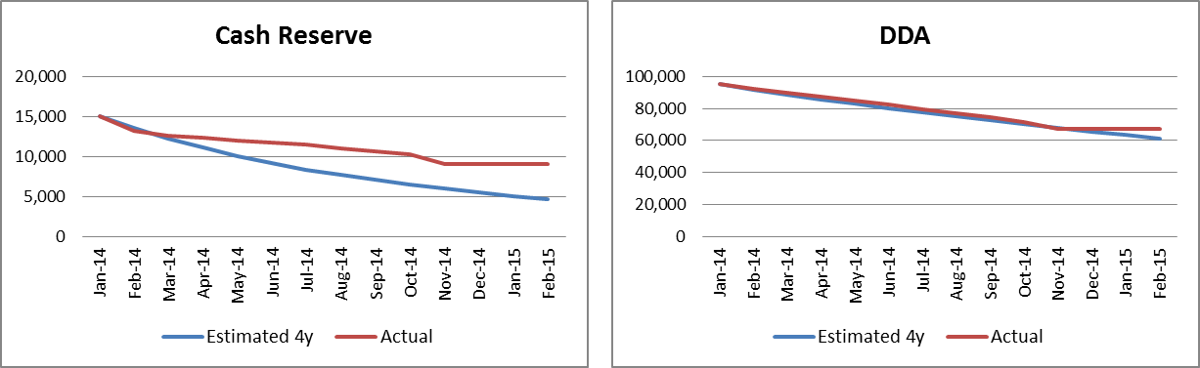

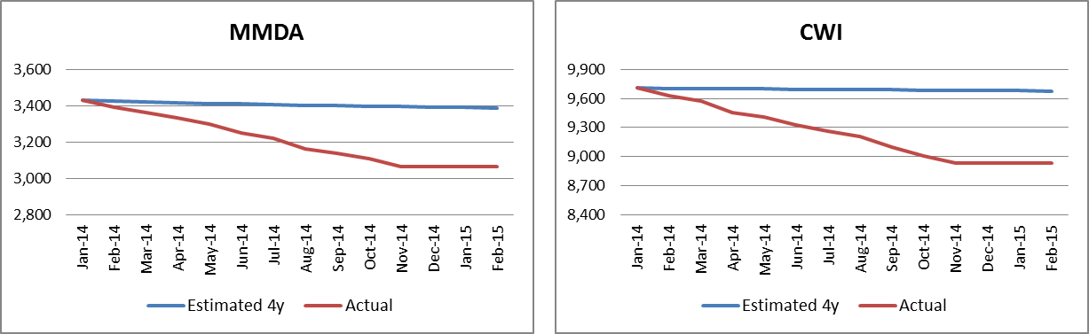

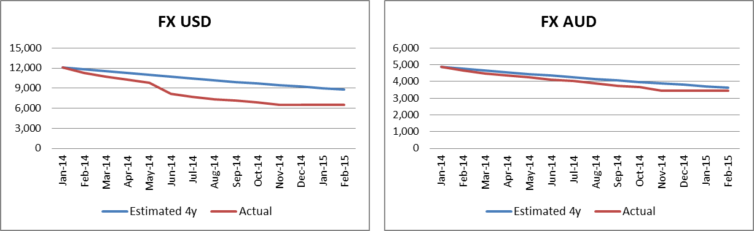

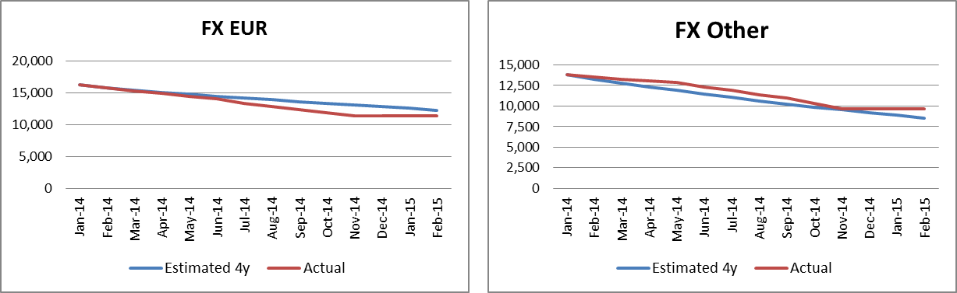

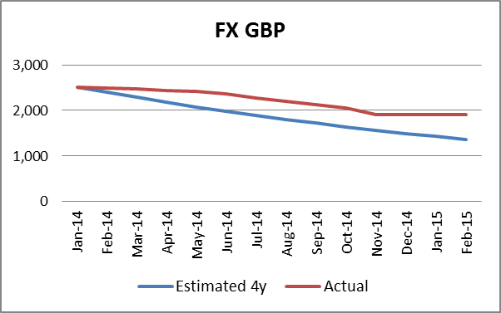

For most products, the estimated number of active accounts is lower than the actual number of active accounts, yielding lower duration. In these instances, the model estimates a more conservative attrition. The number of active accounts per month and per product can be reviewed in the “Number of active accounts per month and per product” spreadsheet attached in the Appendix D.

For CWIs, MMDAs and Cash Reserves, the trend in the estimated vs. actual number of active accounts diverges significantly over the test period. This stems from limitations in the data set. Since CWIs and MMDAs deposit data is not available between Jan 2010 and September 2011, the estimated decay rate vector for these products is not as robust as other products having the full data set. On the other hand, Cash Reserve accounts are stable for the first three years yielding poor decay rate vectors that produce poor estimates and thus the divergence between estimated and actual decay.

The model presented in this document is based on the entire 5 years of data and therefore has a smaller estimation error than Out-of-Sample test as shown below.

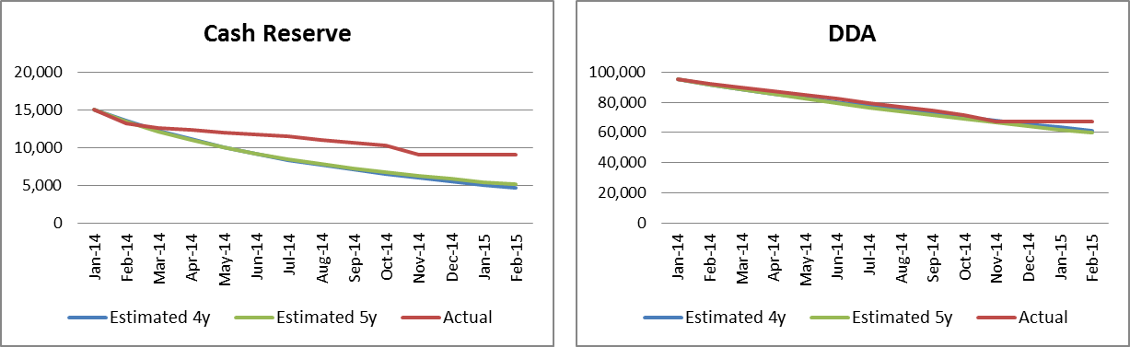

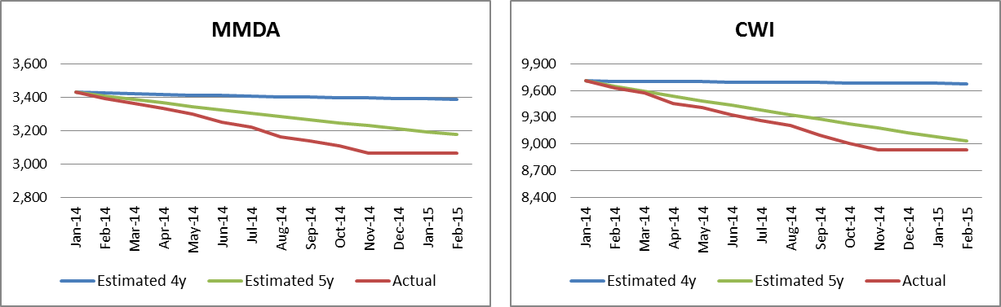

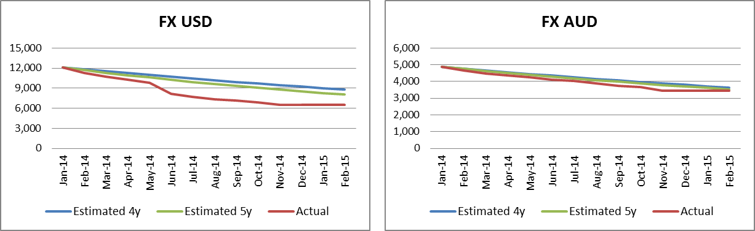

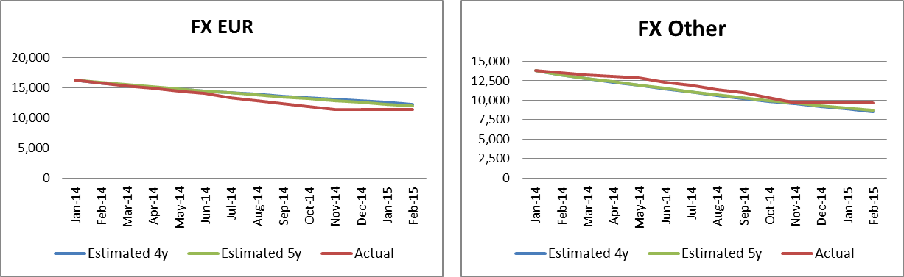

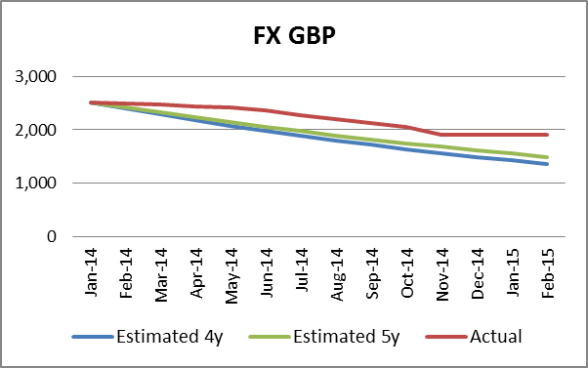

##### **Model Stability Analysis**

As the SA/NV model is built using shirt period of historical data, we performed model stability test to observe model performance by adding incremental data points to the historical data. We estimated the runoff function with data from December 2013 through December 2014, to March 2015, and to June 2015, and we compared each runoff vector to the full dataset to test the stability of the two years of historical data.

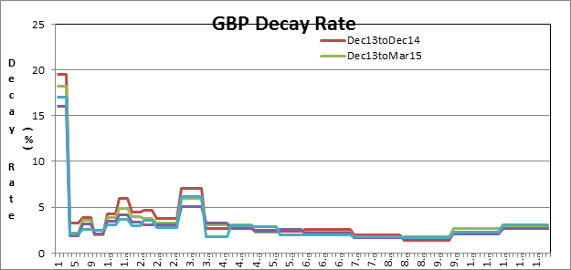

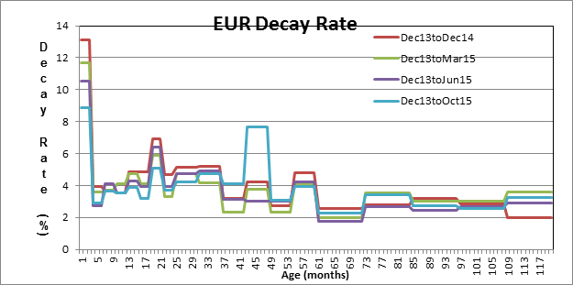

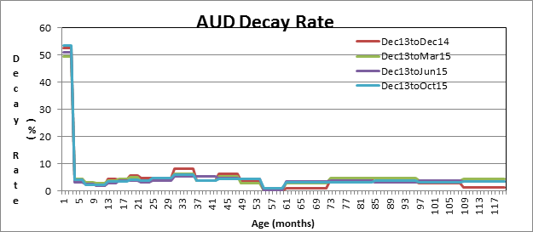

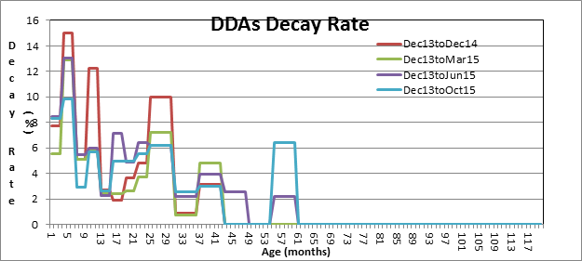

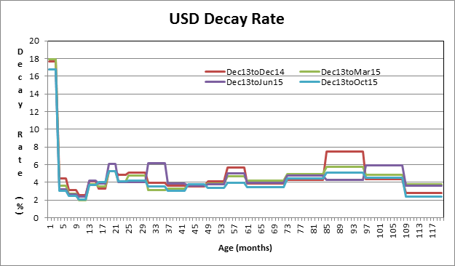

#### **Repricing Function Testing**

##### **Assumption Validity**

1. Assumption 1:

Absolute client rates have stronger linear relationship with interest rates than relative rates (incremental amount from the previous period) do, in that R2 are much higher for levels than for changes in rates. However, given non-stationarity in the dependent variable, a linear regression should be done on transformed variables using first differences, for example, instead of using the dependent variable.

The table below demonstrates regression results for both absolute rates and relative rates: absolute rates show much more significant linear relationship than relative rates.

Figure 22 Comparisons of R-Squares between Absolute Rates and Relative Rates

|  |  |  |
| --- | --- | --- |
|  | **R-Squares (All available periods)** | |
| Deposit Product | Absolute | Relative |
| AIS Cash Reserve | 0.00 | 0.05 |
| Asset Servicing Cash Reserve | 0.98 | 0.49 |
| Asset Servicing CWI (CIBC) | 0.96 | 0.52 |
| Asset Servicing USD | 0.83 | 0.05 |
| Asset Servicing EUR | 0.93 | 0.31 |
| Asset Servicing GBP | 0.30 | 0.14 |
| Cash Mgmt CWIs | 0.92 | 0.07 |
| Cash Mgmt MMDAs | 0.98 | 0.47 |
| Corp Trust Cash Reserve | 0.96 | 0.56 |
| Glob Liq Svcs Cash Reserve | 0.03 | 0.00 |
| LNI | 0.98 | 0.80 |
| Total Corporate Trust USD | 0.92 | 0.39 |
| Total Corporate Trust EUR | 0.84 | 0.74 |
| Total Corporate Trust GBP | 0.86 | 0.58 |
| WMB CWIs | 0.42 | 0.01 |
| WMB Private Banking MMDAs | 0.92 | 0.62 |
| WMB Savings | 0.72 | 0.07 |
| WMB Sweep MMDAs | 0.99 | 0.49 |

We also looked at the forward Fed Funds Effective rates and the forward deposit rates computed in QRM using the results (beta and intercept) from the regression run on absolute rates for Asset Servicing Cash Reserve. We then calculated the beta on these forward rates as follows:

$$β=\frac{∆Coupon Rate}{∆Fed Funds Effective}$$

The results are provided in the spreadsheet “Deposit_USD_var Drill-DownAS_CR xlsx” attached in Appendix. The beta derived from the regression based on change in forward rates is exactly the same as the beta derived from absolute rates as shown in figure 11. Using absolute rates to derive the beta is therefore a reasonable assumption.

2. Assumption 2: The data used to derive the beta for deposits in USD is from the period where interest rates were rising. This is in the interest of any forecasting exercise as today’s market signals are pointing toward an increase in Fed Funds Effective rate.

The figure below illustrates Fed Funds Effective Forward Rates curve, which indicates that the rate will go up in the future.

Figure 23 Fed Funds Effective Forward rate

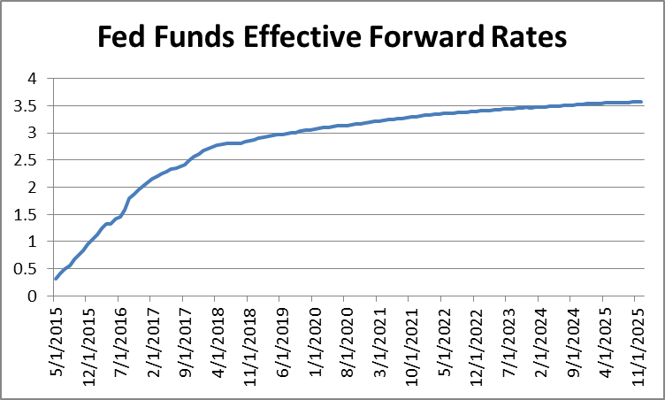

Figure 13 illustrates the expectation of Fed Funds Rate from Bloomberg, which shows larger probabilities for a rising rate environment.

Figure 24 Probabilities of Fed Funds Rate Change

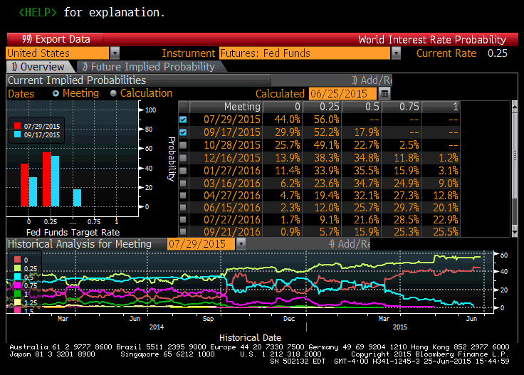

Assumption 3: Asset Servicing Cash Reserve beta result is used as a proxy for Global Liquidity Service Cash Reserve and Alternative Investment Services Cash Reserve because there is no historical clients’ rates data for Global Liquidity Service Cash Reserve and AIS Cash Reserve before 2008.

##### ****Results testing****

Estimation errors of regression model are defined as below and presented in Figure 21.

$$Estimation Error=\left[β*\left(Interest Rate\right)+Intercept\right]-Actual Deposit Rate$$

Figure 25 Standard Error of regression for each deposit type

|  |  |
| --- | --- |
| **Product** | **Standard Error** |
| Asset Servicing Cash Reserve | 0.00146 |
| Asset Servicing CWI (CIBC) | 0.00147 |
| Asset Servicing USD | 0.00230 |
| Cash Mgmt CWIs | 0.00160 |
| Corporate Trust Cash Reserve | 0.00219 |
| Glob Liq Svcs Cash Reserve | 0.000292 |
| LNI | 0.000613 |
| Total Corporate Trust USD | 0.002962 |
| WMB CWIs | 0.00055 |
| WMB Private Banking MMDAs | 0.003261 |
| WMB Savings | 0.00185 |
| WMB Sweep MMDAs | 0.001217 |
| Asset Servicing EUR | 0.001893 |
| Asset Servicing GBP | 0.000637 |
| Total Corporate Trust EUR | 0.000418 |
| Total Corporate Trust GBP | 0.000341 |

*Cash Mgmt MMDAs and AIS Cash Reserve are not included because WMB Private Banking MMDAs is used as their proxy.

### Analysis of Implementation

To validate implementation of the model in QRM, the following sample tests were conducted.

1. Runoff Function Implementation Test

Step 1: Take sample accounts from QRM and review their decay rates throughout the test time horizon.

Step 2: Compute the account’s age and match the decay rate from the model.

Step 3: Compare the decay rates from the model and the decay rates from QRM and confirm whether there is discrepancy.

2. Repricing Function Implementation Test

Step 1: Take sample accounts from QRM and review their betas.

Step 2: Compute the coupon rates using the rate index and beta/intercept given by the model.

Step 3: Compare the coupon rates from Step 2 and the coupon rates from QRM and confirm whether there is discrepancy.

A snapshot of sample testing is depicted below:

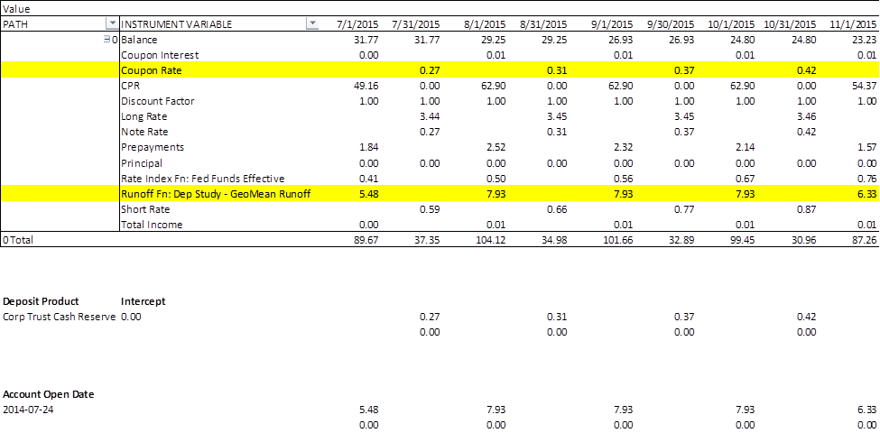

Detailed results of sample tests can be found in Appendix F.

### Ongoing Performance Monitoring Plan

1. Frequency of the on-going monitoring:

Attrition Model back testing will be performed on a monthly basis. Projected 1st month balance runoff from the model will be compared to the realized monthly runoff.

For SA/NV, the back testing will be performed quarterly.

Additionally, the core/excess split will be updated quarterly. The months within the quarter will maintain the same core balance as the previous quarter end, and the difference between the stable core and the total balance is assumed to be the excess.

1. Reviewer(s) of the on-going monitoring results:

The results will be reviewed by the Head of Interest Rate Risk and presented in the monthly Treasury Risk Committee (TRC) package.

For SA/NV, the results of the model will be reviewed quarterly.

1. Trigger/threshold for action requirements:

Action(s) will be triggered based on the monthly variance between model projected decay rates and actual balance runoff rates. The threshold is established as the average 1-month variance over the most recent three months. This average variance is not to exceed 10% of the model predicted decay rates at the segment level. For Operational Deposits, testing will be conducted at segment core deposit level as well. In cases where the actual decay rates are smaller than the model predicted no actions will be triggered.

1. Escalation path/actions if actions are triggered:

If results show projected runoff being higher than the actual then our model is viewed as conservative and no further action will be required. If projected balance runoff is less than the actual, breaching the established thresholds, then the model will be scaled to achieve the actual runoff. Treasury Risk Committee will have the authority to approve an exception.

1. Escalation records to be logged and delivered to MRMG:

MRMG will receive the records as part of the TRC package.

## Revision History of Model

|  |  |  |  |  |
| --- | --- | --- | --- | --- |
| **Date** | **Section** | **Description of Change** | **Validation of Change** | **Validation Date** |
| 7/15/2015 | All | The documentation was submitted to Model Validation | Validated | 7/30 |
| 7/29/2015 | (1) Testing the Model > C. Analysis of Implementation  (2) Testing the Model > D. Ongoing Performance Monitoring Plan  (3) Model Specification > B. Methodology > 2. Repricing Function > Assumptions | (1) Analysis of Implementation was updated.  (2) Ongoing Performance Monitoring Plan section was updated.  (3) Some of beta sensitivity analyses were rerun using all available periods. (Assumption 5 in Repricing Function) | Validated | 7/30 |
| 7/31/2015 | (1) Model Specification > A. Model Approach  (2) Purpose and Use > C. Model Family  (3) Model Specification > B. Methodology > 2. Repricing Function > Data for Model Development  (4) Testing the Model > B. Analysis of the Model > 1. Runoff Function > Assumption Validity  (5) Model Specification > D. Model Impact to Current Valuation and EVE Sensitivity  (6) Revision History of Model | The documentation was updated per “Review of Policy Compliance” part in Model Validation Report  (1) Chart on page 4 was updated  (2) Added Model #2436  (3) Created “Data for Model Development”, and separated from “Input Data and Data Assumptions”  (4) In Assumption 1, the correlation for GBP deposits was updated; in Assumption 3, the reference to Appendix was updated  (5) Added the Truncation part to Section E. Model Impact to Current Valuation and EVE Sensitivity  (6) Revision history was updated | To be validated |  |
| 8/12/2015 | Testing the Model > A. Model Outputs > 2. Repricing Function;  Appendix C | The documentation about QRM Implementation was revised per the update on the QRM function. |  |  |
| 8/26/2015 | (1) Model Specification > A. Model Approach  (2) Model Specification > B. Methodology > 1. Runoff Function > Formulation  (3) Model Specification > D. Model Impact to Current Valuation and EVE Sensitivity | (1) Updated the chart on page 4  (2) Corrected the decay rate computation table on page 7; Clarified use of geometric average and indexation on pages 7 and 8  (3) Clarified data used for (i) testing the impact of truncation point to duration and (ii) model impact to valuation and EVE sensitivity on page 18 |  |  |
| 9/15/2015 | (1) Model Specification > Methodology > 1.Runoff Function > Formulation  (2) Model Specification > Methodology > 1.Runoff Function > Formulation  (3) Testing the Model > A. Model Outputs > 1. Runoff Function  (4) Appendix > C. QRM Implementation | (1) Changed the threshold for censored accounts from $100 to $1,000  (2) Changed the calculation steps table, formula in Step 1 to calculate $Y_{i}$ from geometric mean to arithmetic mean and explanation accordingly, added comment in Step 3 for decay rate computation when missing values  (3) Updated the decay rate charts and decay rates computation table  (4) Updated the non-core % table for operational and non-operational based on June 2015 month end |  |  |
| 9/22/2015 | (1) Testing the Model > B. Analysis of the Model > 1. Runoff Function > Approach Testing  (2) Appendix A. Model Specification | (1) Updated Out-of-Sample test results with 4- year training data and 1-year testing data  (2) Included R code for Runoff Model |  |  |
| 9/24/2015 | (1) Model Specification > B. Methodology > 2. Repricing Function  (2) Model Specification > D. Model Impact to Current Valuation  (3) Testing the Model > A. Model Outputs > 2. Repricing Function  (4) Testing the Model > B. Analysis of the Model > 1. Runoff Function> Parameters sensitivity  (5) Testing the Model > B. Analysis of the Model > 2. Repricing Function Testing | (1) Updated assumptions regarding non-stationarity and updated formulation  (2) Updated Valuation and EVE sensitivity reports per the revised model  (3) Updated Model Output from the revised model  (4) Updated sensitivity analysis results  (5) Updated Assumption Validity section per the revised assumptions |  |  |
| 6/3/2016 | (1) Model Specification >B. Methodology > 1. Runoff Function  (2) Model Specification >B. Methodology > 2. Repricing Function  (3) Model Specification >C. Input Data and Data Assumptions > 2. Repricing Function  (4) Testing the Model >A. Model Outputs> 1. Runoff Function  (5) Testing the Model >B. Analysis of Model> 1. Runoff Function  (6) Testing the Model >D. Ongoing Performance Monitoring PLan | (1) Added comment about SA/NV product types; added graphs and correlation table for SA/NV active accounts versus balances; Mean versus median table; how SA/NV is filtered out of BHC data  (2) SA/NV regression output and explanation  (3) Data source for SA/NV data  (4) Charts comparing decay rates for SA/NV with BHC  (5) Correlation table for SA/NV; Graph showing runoff speed versus short term rates for SA/NV; parameter sensitivity for SA/NV  (6) Added frequency and review of results for SA/NV |  |  |
| 7/1/2016 | (1) Purpose and Use>D. Limitations  (2) Model Specification >B. Methodology > 1. Runoff Function  (3) Model Specification > D. Model Impact  (4) Testing the Model >A. Model Outputs> 1. Runoff Function  (5) Testing the Model >B. Analysis of Model> 1. Runoff Function | (1) SA/NV model uses two years of historical data  (2) Updated mean vs median table; updated data source information  (3) Updated EVE results for SA/NV  (4) Updated runoff graphs  (5) Updated parameter sensitivity for SA/NV; added graphs showing stability of results |  |  |

## Appendix

### Model Specification

* Tag table: 
* Valuation Report: 
* EVE sensitivity analysis: 
* Deposit Runoff Implementation (R code): 

### Input Data and Data Assumptions

* Queries for BWH data:
  + Queries to extract BWH data to the lake
  + Query to compile and pivot BWH data
* Queries for ALMIS data:
* ALM account short name tagging logic: 

### QRM Implementation

* Core / Non-Core split for Operational deposits lookup table: 
* Prepayment function

depositproduct=[P:CUSTOM1];

LOB= [P:Reclass Line of Business];

ODM_L=[P:Operational Deposit Class US LCR];

Current_Age=[P:Instrument Age][0];

SMM_MTbl= Lookup([MdLkup:Deposits Decay Rate Vectors]);

SMM_age=IIF(Current_Age > 240, 3, min(100, max(SMM_MTbl, 0)));

SMM=IIF(Period(0) = 120,100, min(100, max(SMM_MTbl, 0)));

NonCore_Op= Lookup([LKUP:Deposits_Operational_NonCore],LOB);

NonCore_NonOp= Lookup([LKUP:Deposits_Operational_NonCore],'Non Operational Excess');

/*ONpct_A= IIF(ODM_L= 'Operational', NonCore_Op*(100-SMM)/100+SMM,  NonCore_NonOp*(100-SMM)/100+SMM); */

ONpct_A= IIF(ODM_L= 'Operational', NonCore_Op,  NonCore_NonOp);

ONpct= min(100,max(ONpct_A,0));

CASE

  WHEN Period(0) <  2    THEN Min(100,max(ONpct,0))

  WHEN Period(0) >=  2   THEN SMM

ELSE 0

END

### Runoff Function Testing Results

* Balances and Number of Active Accounts

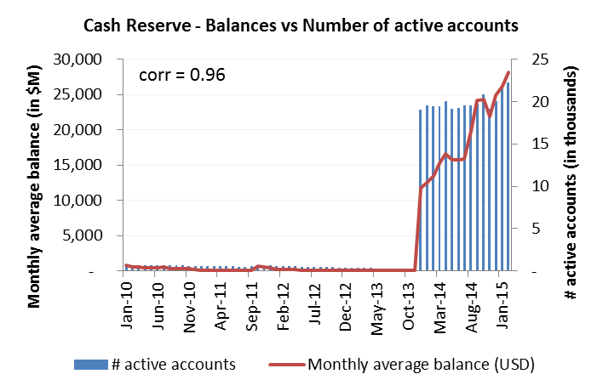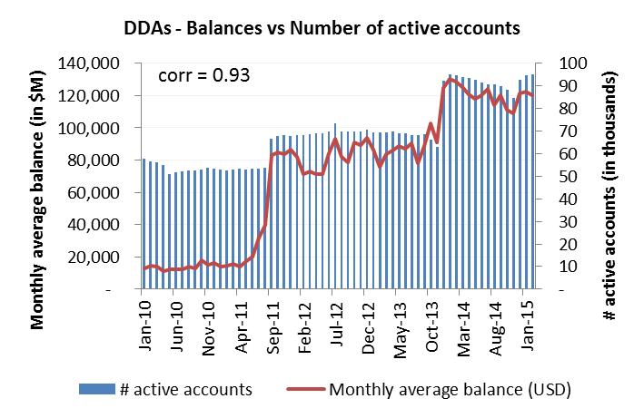

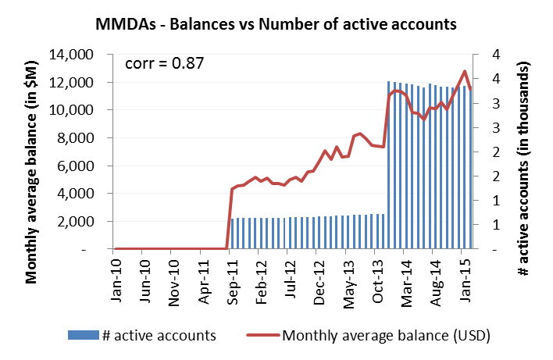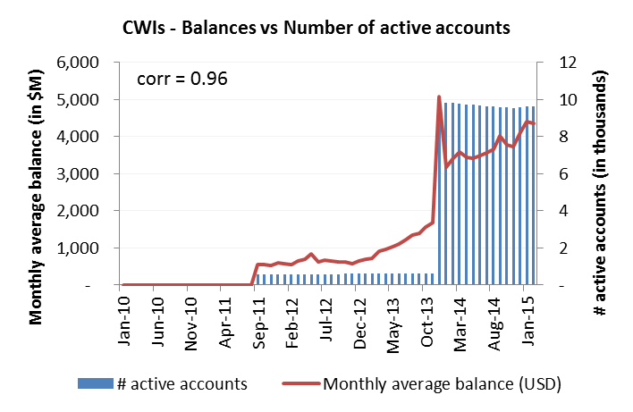

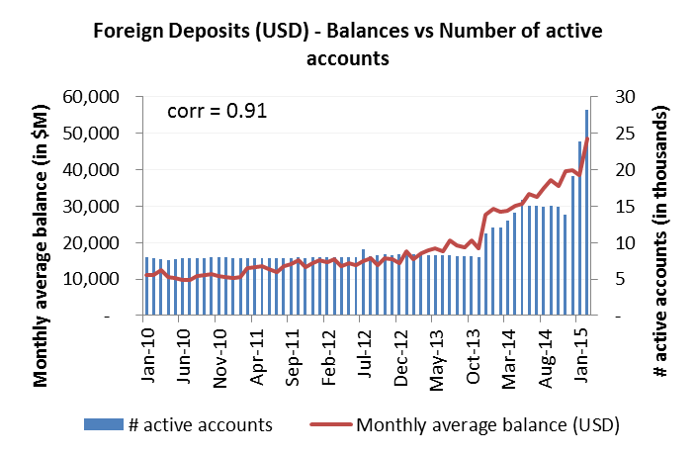 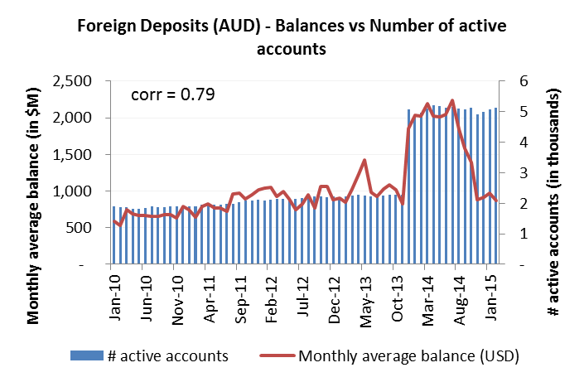

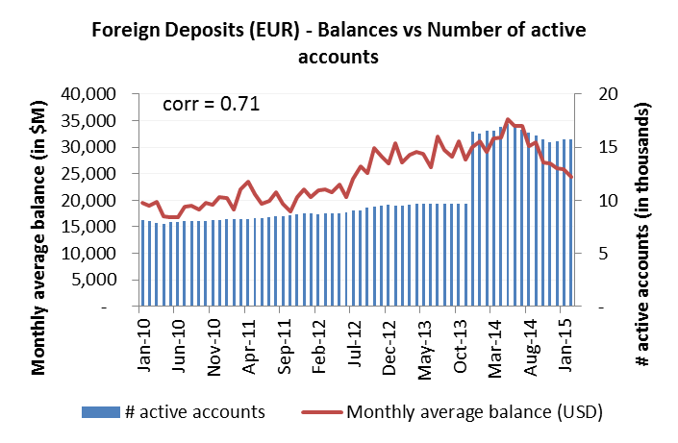 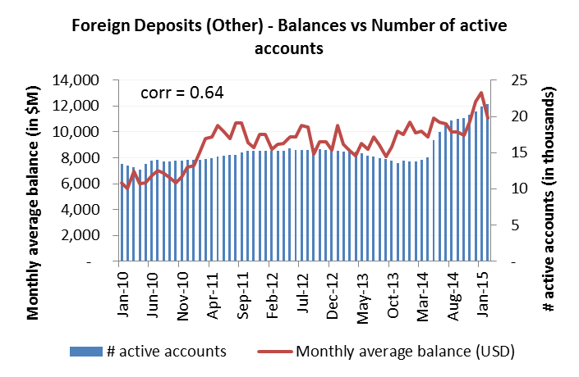

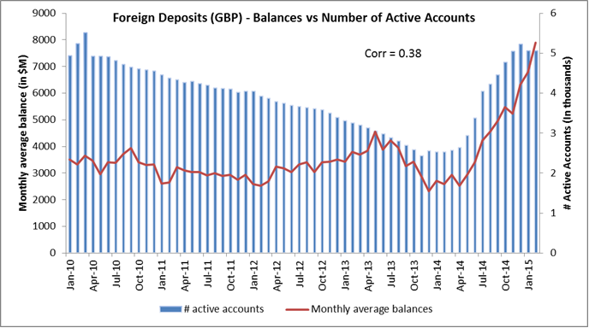

Between January 2012 and January 2014, there are 23 accounts in GBP out of several thousand with monthly average balances above $40M that experience volatility atypical for GBP products and thus distorts the relationship between Balances and Accounts. Upon the exclusion of these accounts, the correlation between GBP Balances and accounts improves from 38% to 71% which is consistent with the correlation observed in other products for the same metrics.

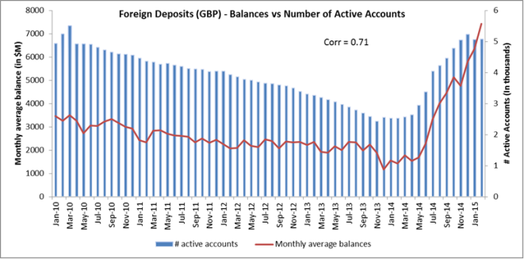

* Number of active accounts per month and per product & LOB combination using a more granular segmentation (alm account short name level): 
* Number of active accounts per month and per product: 
* Operational Deposit definition from the U.S. LCR rule:

“Operational deposit means unsecured wholesale funding or a collateralized deposit that is necessary for the [BANK] to provide operational services as an independent third-party intermediary, agent, or administrator to the wholesale customer or counterparty providing the unsecured wholesale funding or collateralized deposit. In order to recognize a deposit as an operational deposit for purposes of this part, a [BANK] must comply with the requirements of §__.4(b) with respect to that deposit.

Operational services means the following services, provided they are performed as part of cash management, clearing, or custody services:

(1) Payment remittance;

(2) Administration of payments and cash flows related to the safekeeping of investment assets, not including the purchase or sale of assets;

(3) Payroll administration and control over the disbursement of funds;

(4) Transmission, reconciliation, and confirmation of payment orders;

(5) Daylight overdraft;

(6) Determination of intra-day and final settlement positions;

(7) Settlement of securities transactions;

(8) Transfer of capital distributions and recurring contractual payments;

(9) Customer subscriptions and redemptions;

(10) Scheduled distribution of customer funds;

(11) Escrow, funds transfer, stock transfer, and agency services, including payment and settlement services, payment of fees, taxes, and other expenses; and

(12) Collection and aggregation of funds.”

[…]

“(b) Operational deposits. In order to recognize a deposit as an operational deposit as defined in §__.3:

(1) The related operational services must be performed pursuant to a legally binding written agreement, and:

(i) The termination of the agreement must be subject to a minimum 30 calendar-day notice period; or

(ii) As a result of termination of the agreement or transfer of services to a third-party provider, the customer providing the deposit would incur significant contractual termination costs or switching costs (switching costs include significant technology, administrative, and legal service costs incurred in connection with the transfer of the operational services to a third-party provider);

(2) The deposit must be held in an account designated as an operational account;

(3) The customer must hold the deposit at the [BANK] for the primary purpose of obtaining the operational services provided by the [BANK];

(4) The deposit account must not be designed to create an economic incentive for the customer to maintain excess funds therein through increased revenue, reduction in fees, or other offered economic incentives;

(5) The [BANK] must demonstrate that the deposit is empirically linked to the operational services and that it has a methodology that takes into account the volatility of the average balance for identifying any excess amount, which must be excluded from the operational deposit amount;

(6) The deposit must not be provided in connection with the [BANK]’s provision of prime brokerage services, which, for the purposes of this part, are a package of services offered by the [BANK] whereby the [BANK], among other services, executes, clears, settles, and finances transactions entered into by the customer or a third-party entity on behalf of the customer (such as an executing broker), and where the [BANK] has a right to use or rehypothecate assets provided by the customer, including in connection with the extension of margin and other similar financing of the customer, subject to applicable law, and includes operational services provided to a non-regulated fund; and

(7) The deposits must not be for arrangements in which the [BANK] (as correspondent) holds deposits owned by another depository institution bank (as respondent) and the respondent temporarily places excess funds in an overnight deposit with the [BANK].”

### Repricing Function (beta) Testing Results

* Relationship between Deposit Rates and Fed Funds Effective Rates

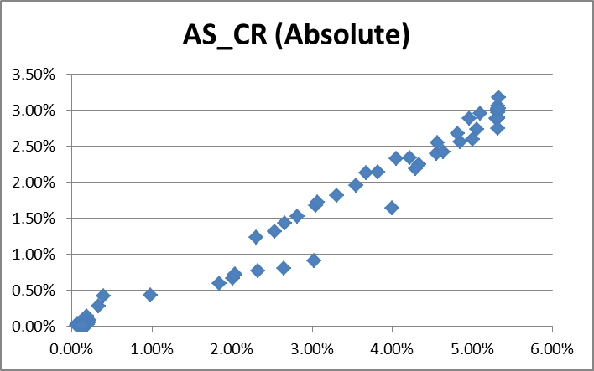 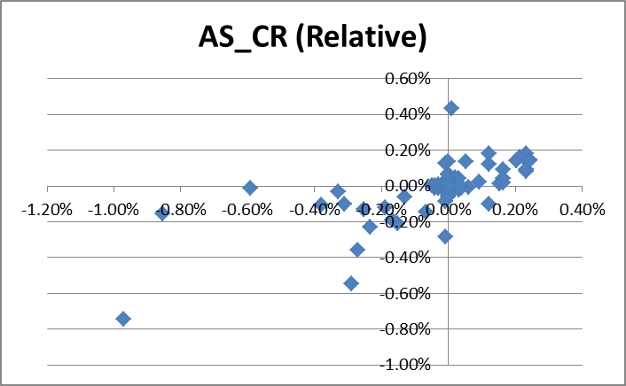

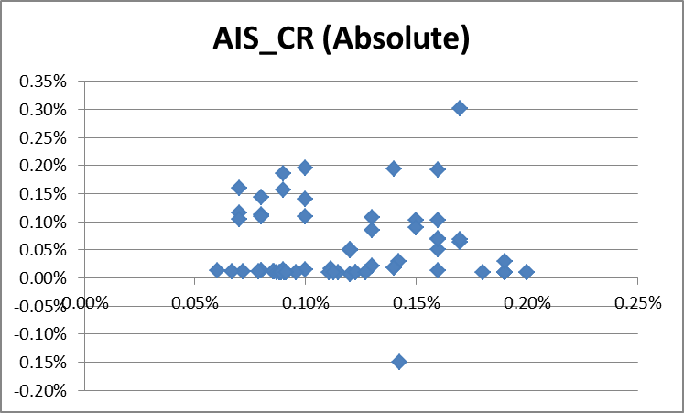 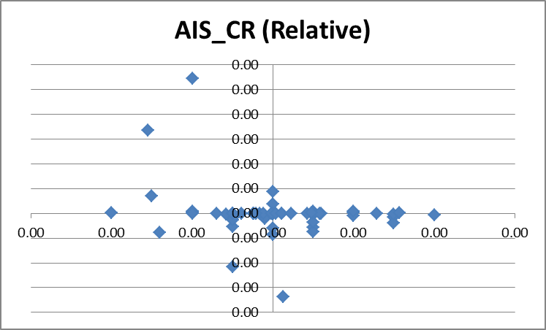

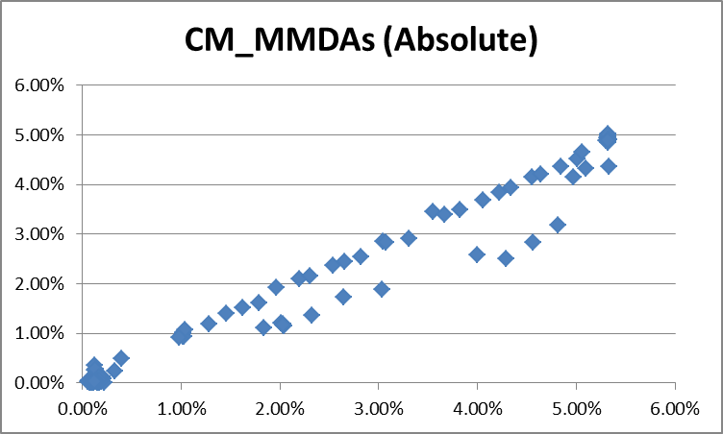 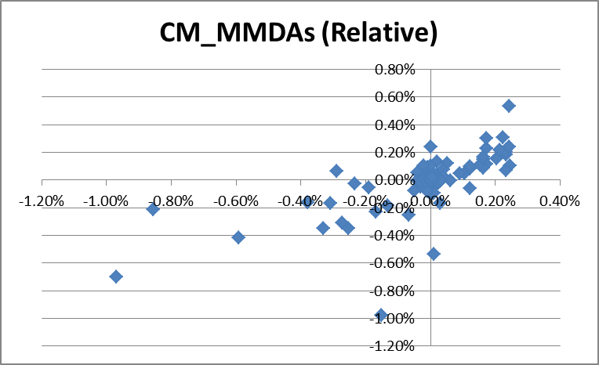

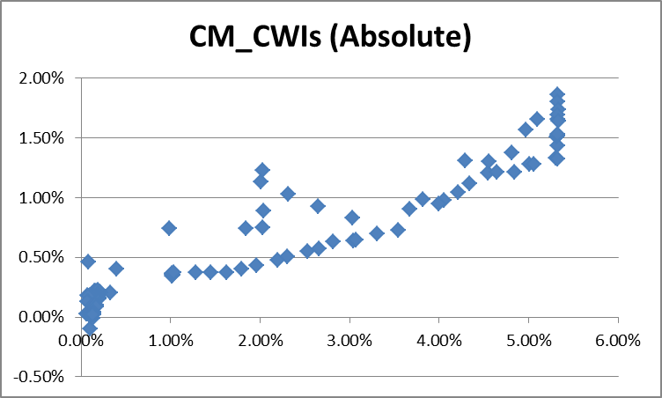 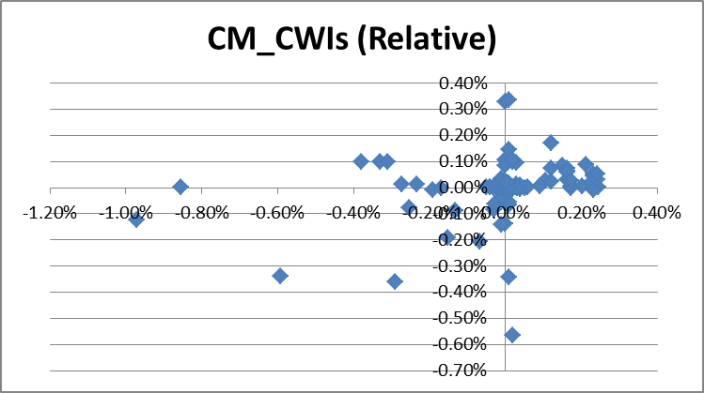

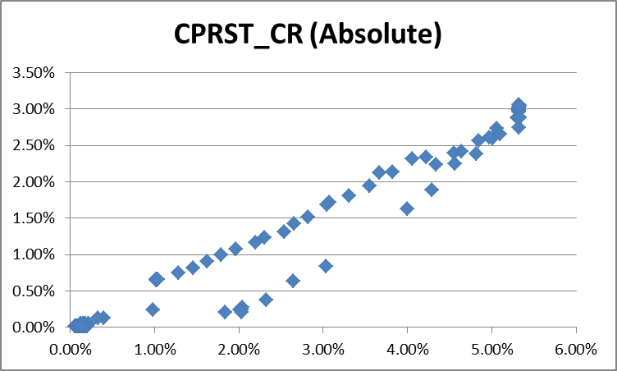 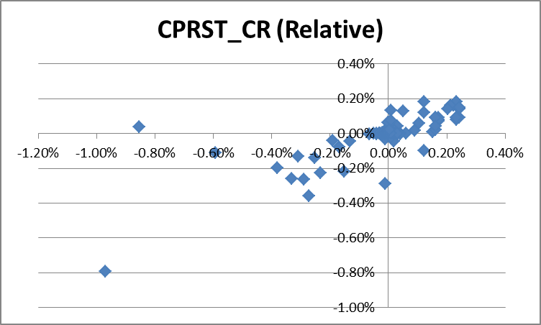

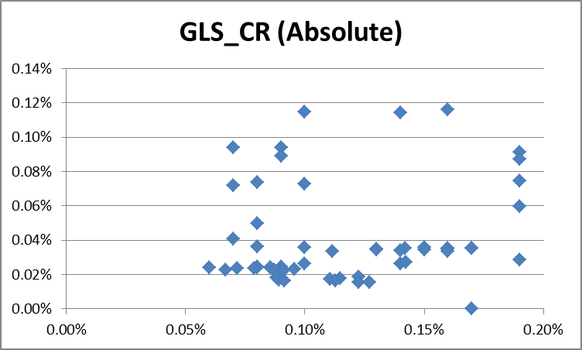 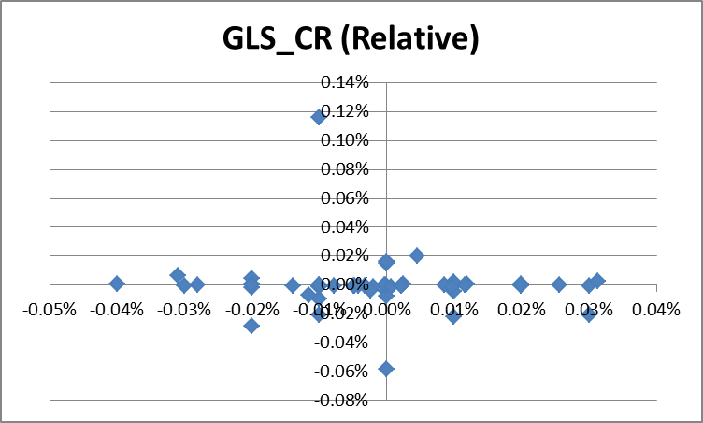

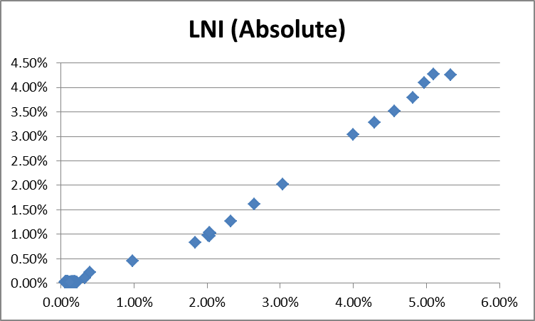 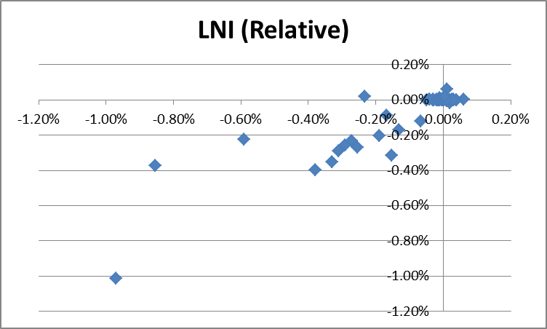

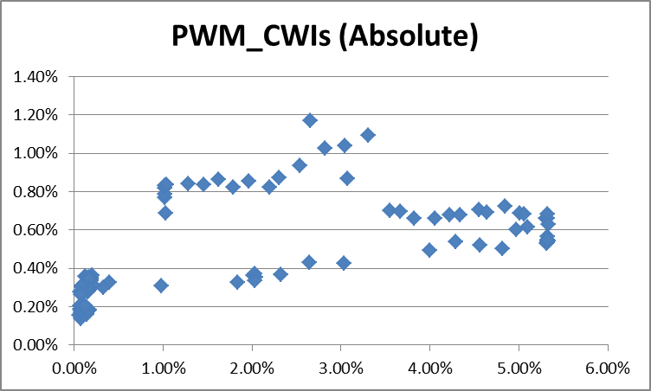 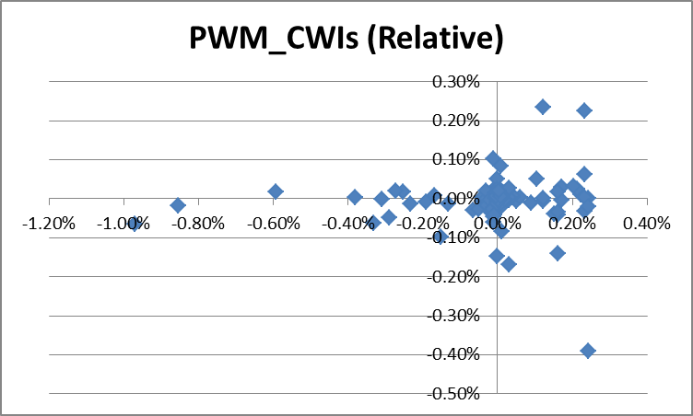

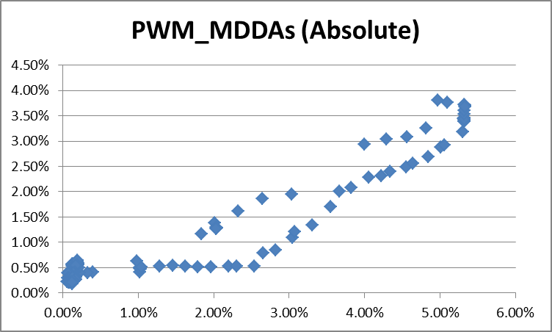 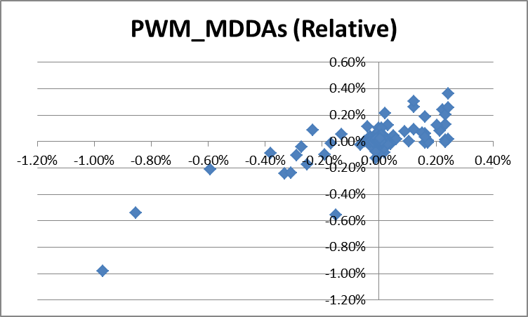

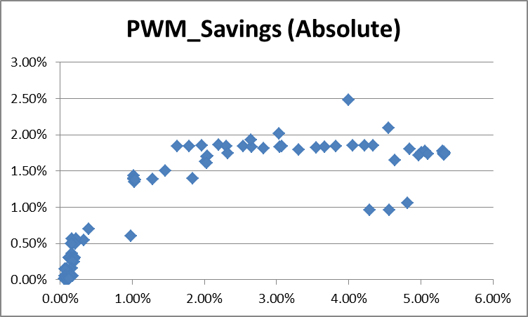 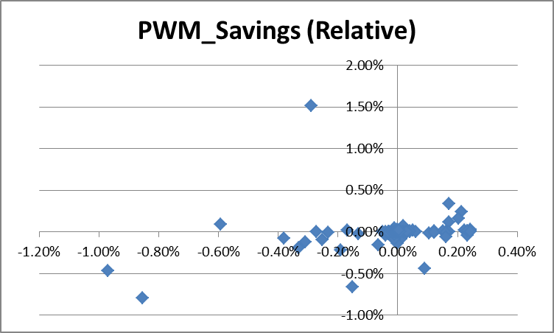

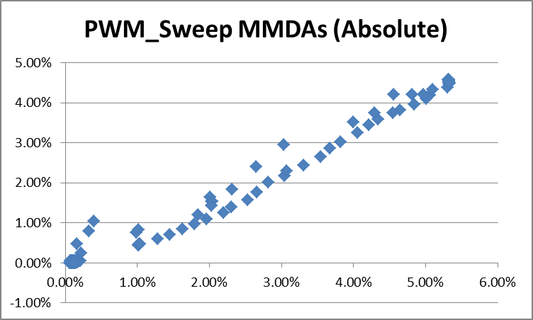 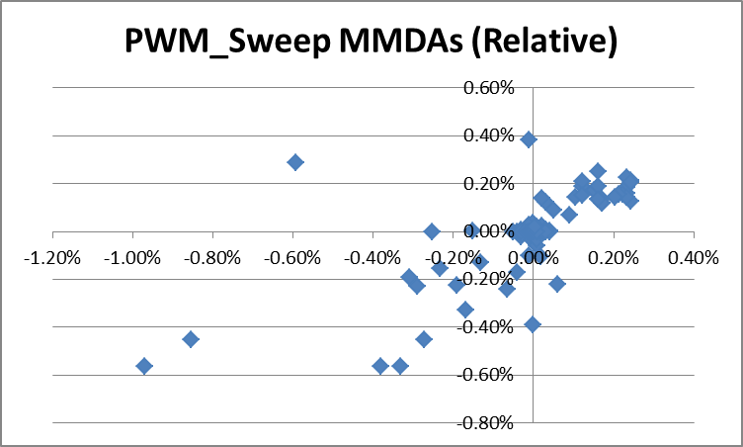

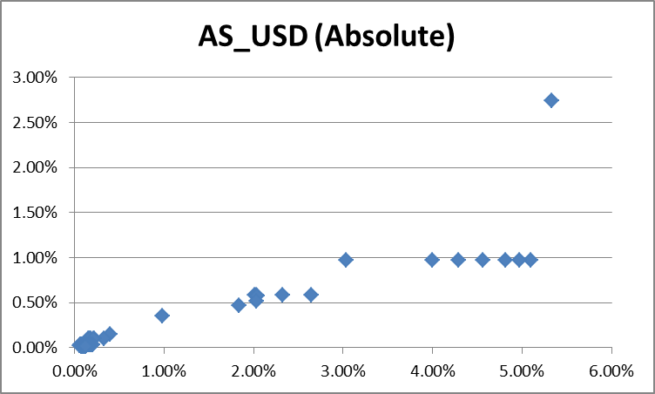 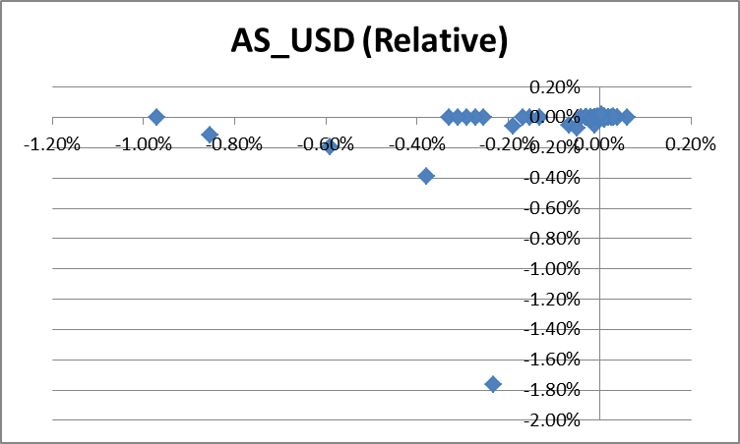

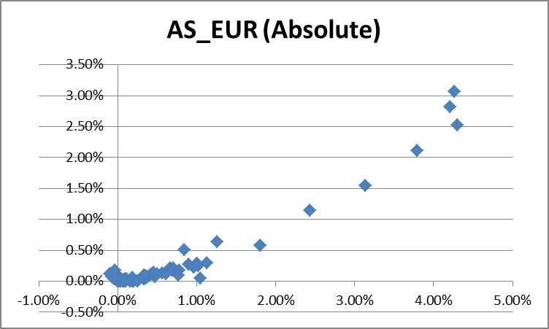 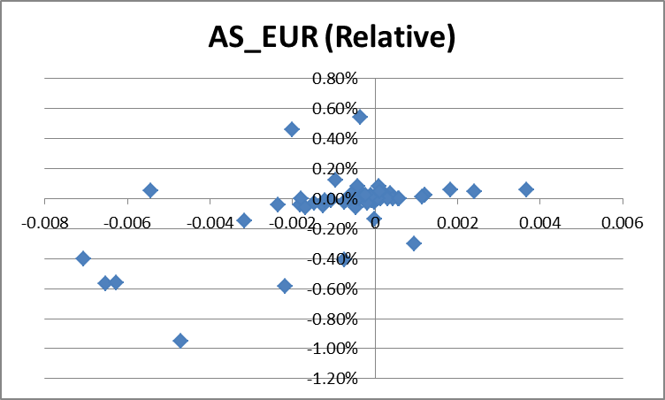

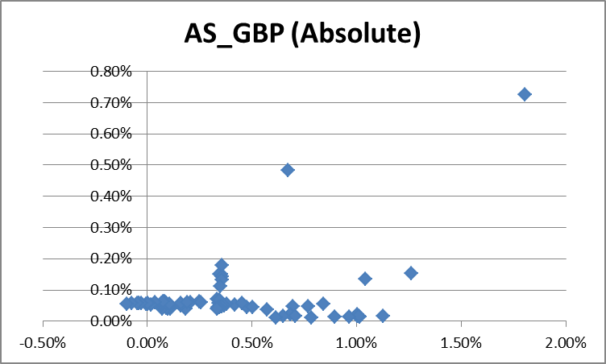 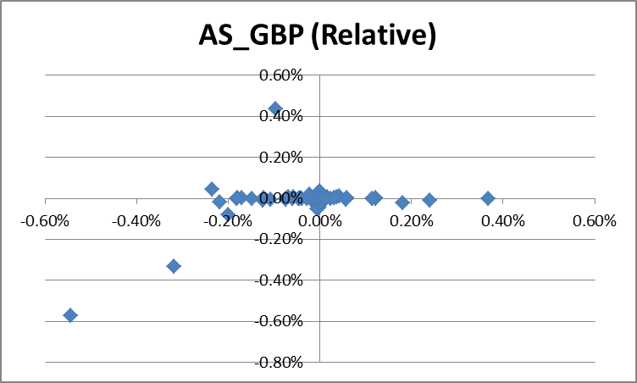

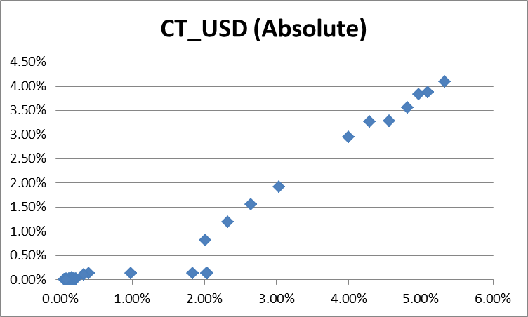 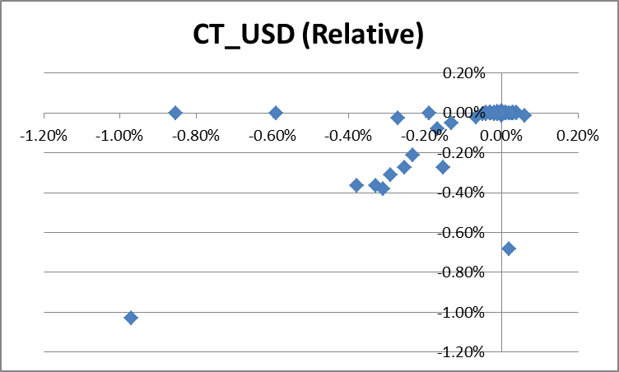

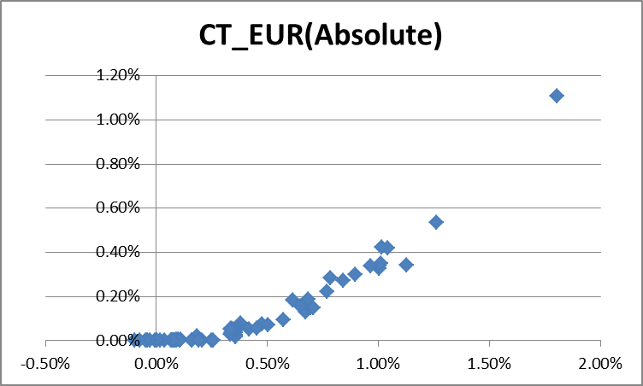 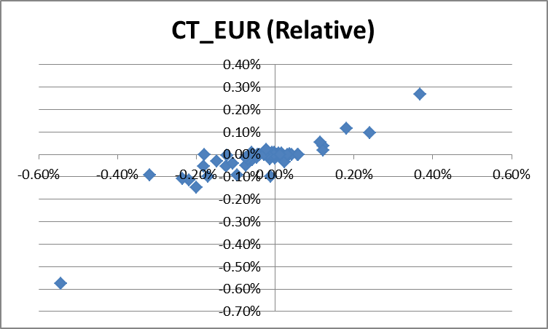

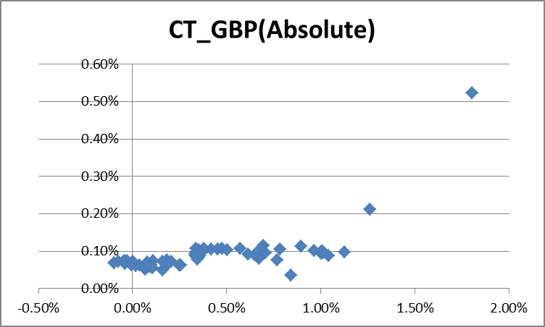 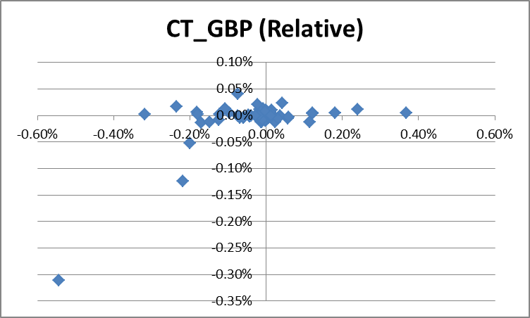

### F. Sample Tests for Model Implementation

Three types of sample accounts were tested as below:

1) Asset Servicing CWI Deposit 

2) Asset Servicing Cash Reserve Deposit

3) Corporate Trust Cash Reserve Deposit